**OutSystems JUMPSTART**

**TABLE OF CONTENTS**

**About this Exercise** **1**

**Create a Web Application** **2**

**Manual Data Modelling (Customer)** **5**

**“Customer” Page Creation** **8**

**Automatic Data Modelling (Product)** **11**

**“Product” Page Creation** **12**

**“Shipping Details” creation** **13**

**“Order” and “Order Lines” creation** **14**

**Gallery Creation using a UI Template** **19**

**Expose the Product entity as public** **25**

**Expose the product catalog as a REST Service** **25**

**Calculating Order Total** **30**

**OutSystems JUMPSTART**

Exercise 1a: Build your own web app [~1 hr]

…………………………………………………………………………………………………………

# About this Exercise

In this exercise you’ll learn how to create your own responsive web application.

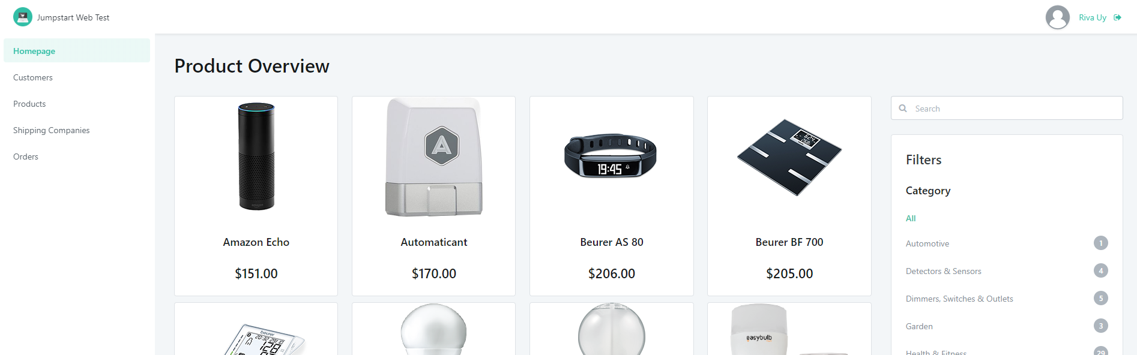

Within this application, you would be able to:

1. Manage **Customer** information
2. Manage **Products** information
3. Manage **Shipping Company** information
4. Manage **Orders**

You would also build and design database tables with the following relationship:

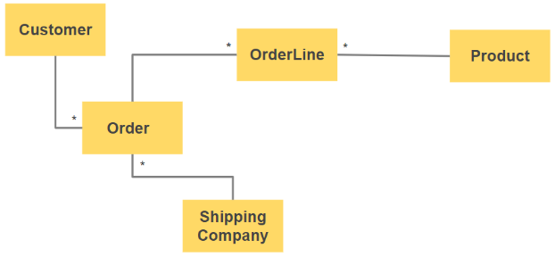

At the end of this set of exercise labs, you will have a small, but perfectly formed application, spanning multiple screens and concepts that you can easily access from a web or mobile browser

In this exercise, you will:

* Create a responsive application
* Create data models and pre-populate data from Excel
* Create listing and detail screens
* Create a gallery page
* Expose a REST API

# Create a Web Application

|  |
| --- |
| In this section you will learn how to create your base web application in OutSystems Service Studio, defining the name, theme and application icon. |

* 1. In OutSystems Service Studio, click **New Application.**

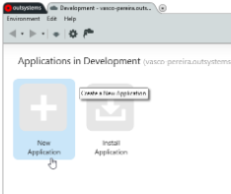

* 1. Select **Web App** and click **Next.**

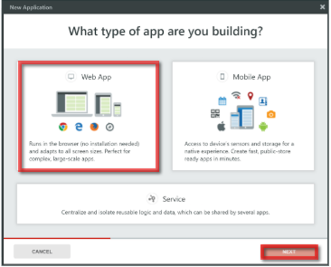

* 1. Select **Side Menu** Template.

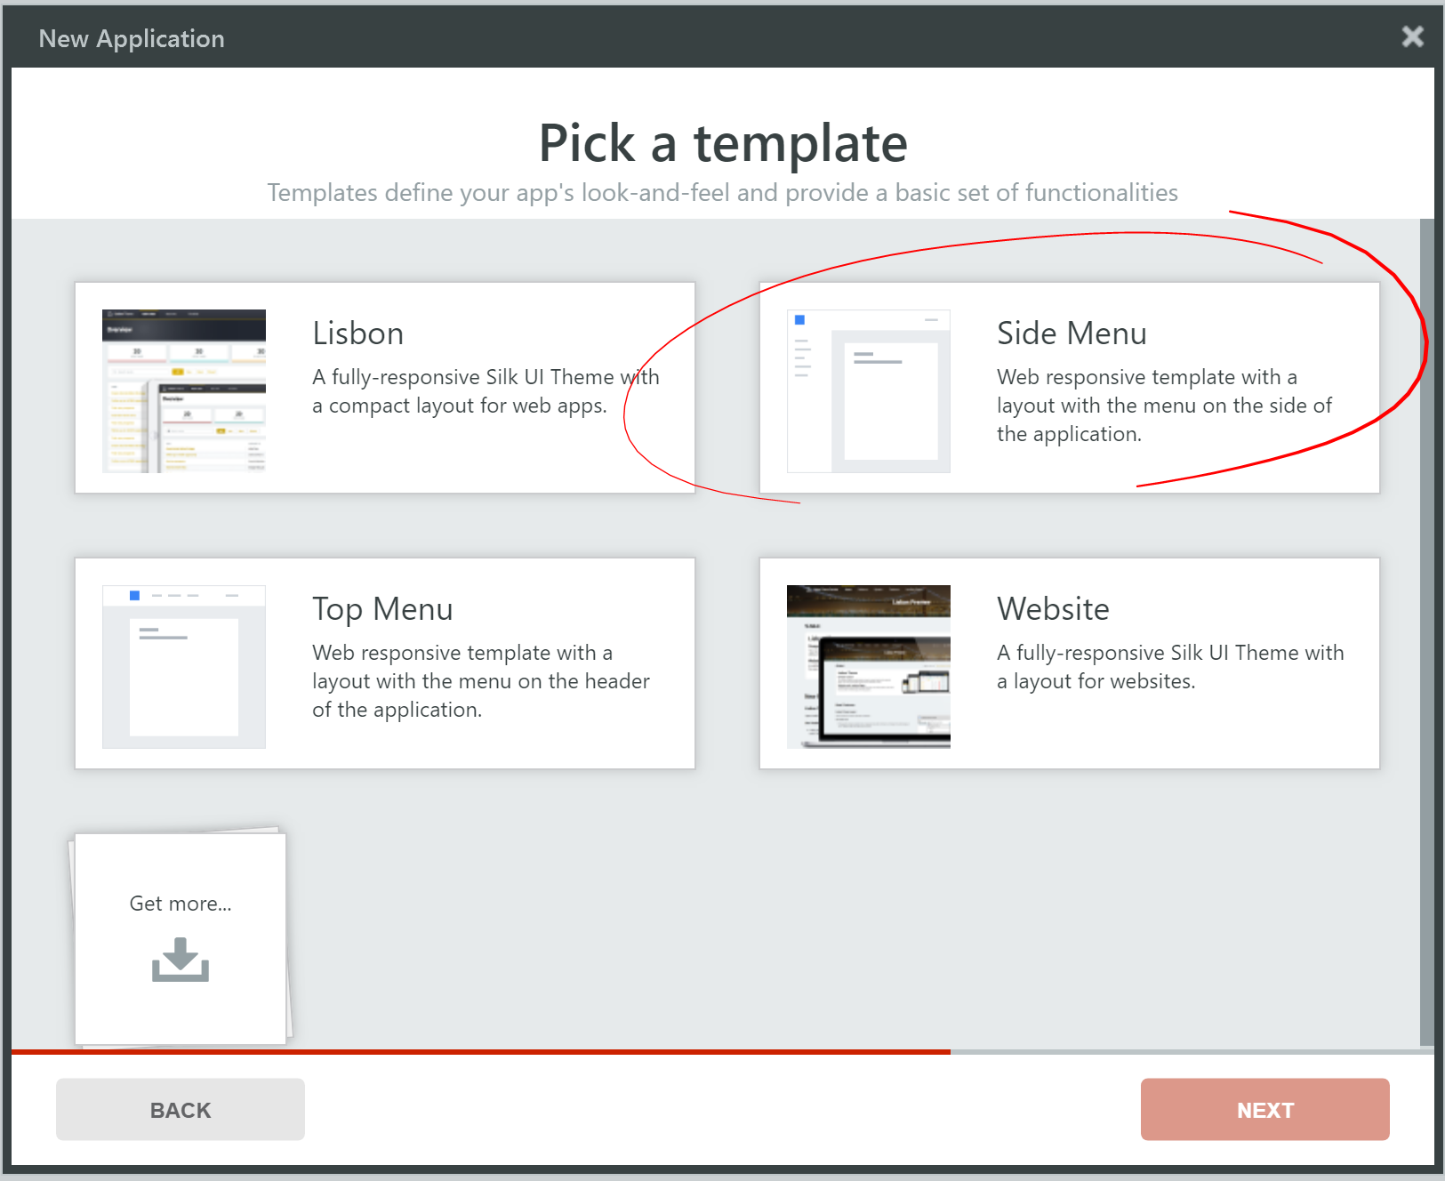

* 1. Name your application **MyJumpstartStore.**  
     Upload the icon provided.

Click **Create App**.

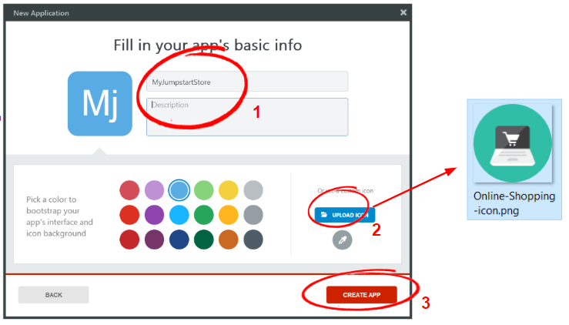

* 1. Create a **Web Responsive** module with the name **MyJumpStartStore.**

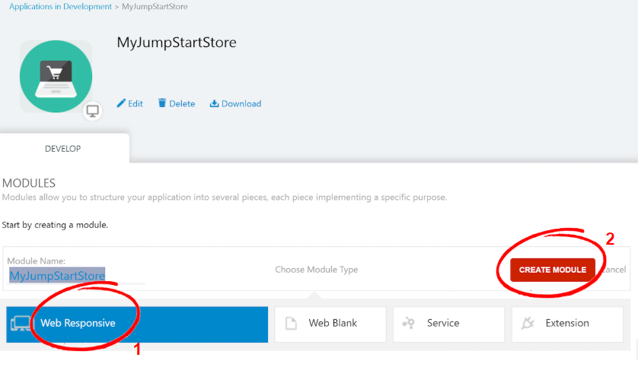

* 1. Go to the **Interface** tab, and click **Themes** > **MyJumpstartStore.**

In the properties panel, set the following values:

* **Pop-up Editor : Layouts\LayoutPopup**Explanation:   
  We are going to use a lot of “Accelerators” during this exercise. Setting this value will help define the popup behavior later on, when we are building a screen with a 1-to-many relationship data model.

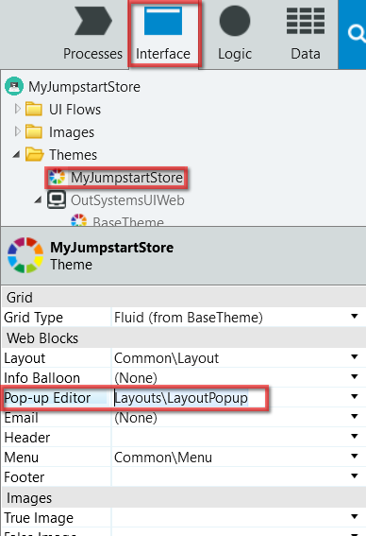

# Manual Data Modelling (Customer)

|  |
| --- |
| In this chapter, you will create your first Entity (database table) of the application.  Entities can be created manually where the developer enters the database design information, or it could be automatically created directly from an Excel file.  In this Exercise we will create the Customer entity *manually*, and then automatically pre-populate the data from an excel file (this is called Bootstrapping). |

* 1. Navigate to the **Data** tab.

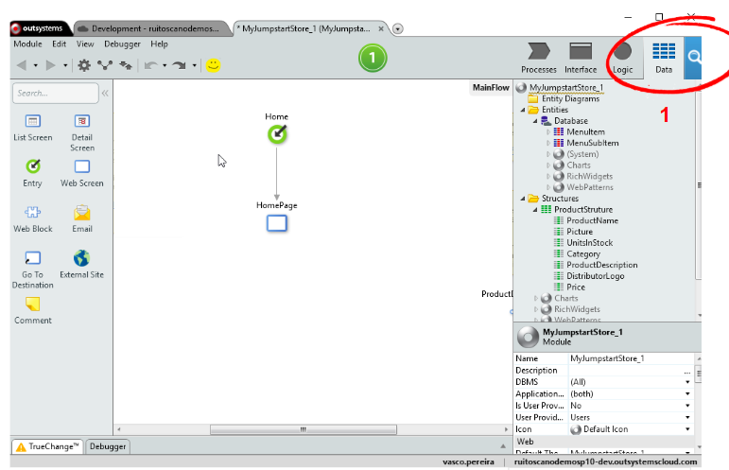

* 1. Manual way of adding
     1. Right click “**Entities**” > “**Database**” > click “**Add Entity**” to create a new entity.
     2. Create the **Customer** entity with the following attributes.  
        *You can create entity attributes by:* Method 1: *Right click entity >* ***New Entity Attribute*** Method 2: *Press* ***Ctrl+N*** *while the Entity (or an existing entity attribute) is selected.*
        + **CustomerName**, Text length 50
        + **MainContactName**, Text length 50
        + **Country**, Text length 50
        + **City**, Text length 50
        + **AddressLine1**, Text length 50
        + **PostalCode**, Text length 50
        + **ContactEmail**, Email
        + **MainPhone**, Phone Number

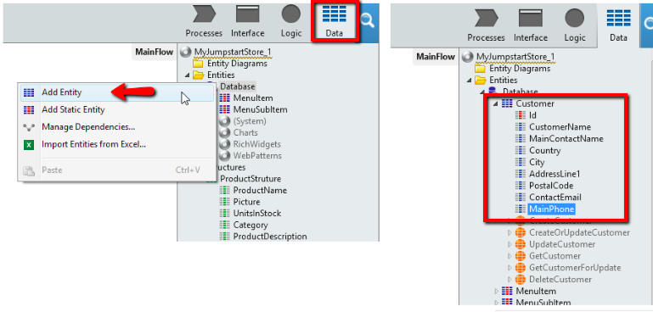

* 1. Bootstrap sample data
     1. After the creation of the **Customer** entity we want to *bootstrap* some information to use as our sample data.   
        To do this right click on the **Customer** entity then go to **Advanced** and then click “**Create Action to Bootstrap Data from Excel...**”
     2. Use the file **Customers.xls** for the bootstrap.

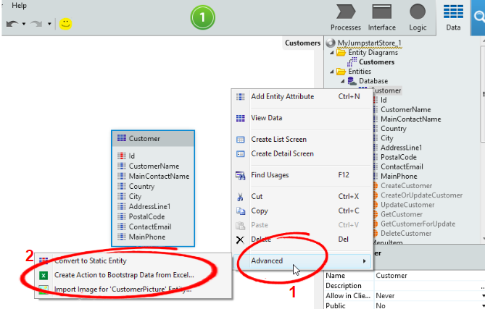

* 1. Map the attributes of the excel file to your **Customer** Entity.
     1. If you have created the entity attributes correctly, including making **attributes name case sensitive**, the bootstrap will match every column from the excel file. Click **Proceed** to continue.
     2. If we find some mismatching, please cancel, correct the attribute names, and repeat the previous step.

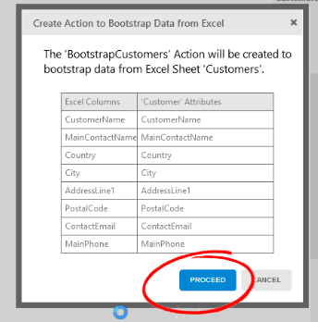

* 1. An **Entity Diagram** in OutSystems helps you visualize the relationship between your entities.   
     Go to the **Entity Diagrams** > **MyJumpstartStoreDataModel**  
     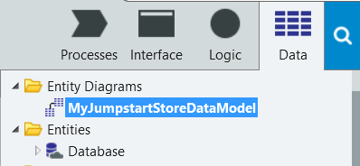
  2. Drag the “**Customer**” entity to the diagram.  
     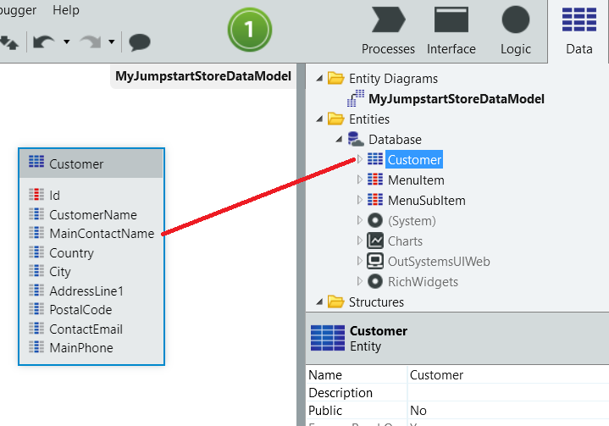 *This diagram will show us how the entities are related to each other.*

# “Customer” Page Creation

|  |
| --- |
| In this chapter, you will create the Customer Listing page and Customer Detail page automatically based on the Customer Entity. |

* 1. Create the **Customers** Listing Page.
     1. Go to the **Interface** tab and double click on the **MainFlow** item.

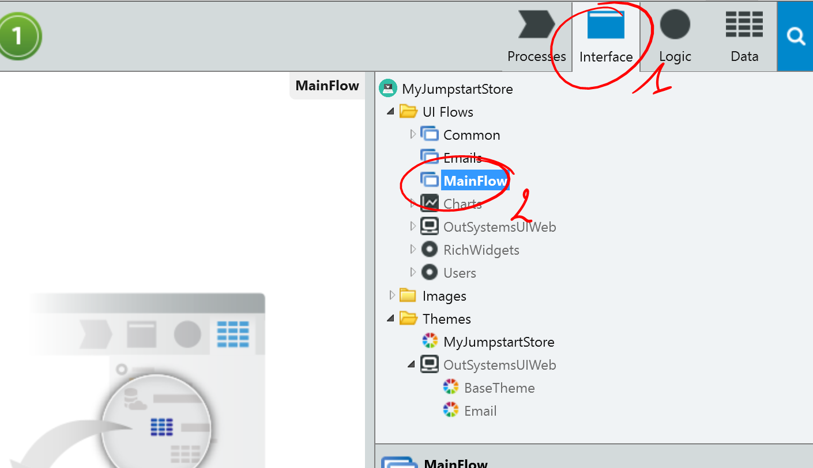

* + 1. Go to **Data** tab and drag the **Customer** entity to the MainFlow canvas on the left

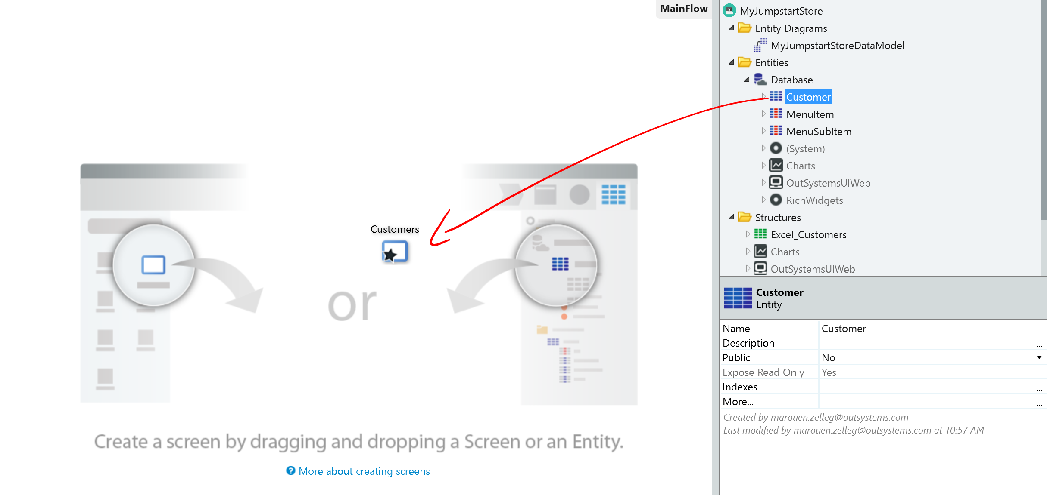

*OutSystems has interface accelerators (called “scaffolding”) to automatically create pages based on Entities.   
The first time you drag an entity into the screen, OutSystems auto-creates a* ***listing*** *page*

* 1. Add a new column in the **Customers** interface.
     1. Go to the **Customers** web page by double-clicking either of these:

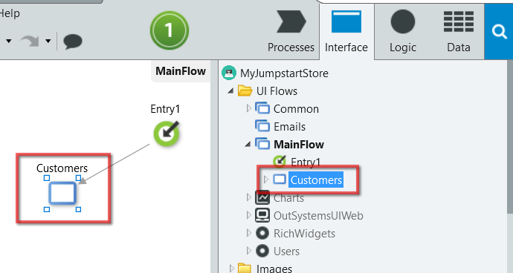

* + 1. Add a new column **Main Phone** by dragging it from the **Data** tab > **Customer** entity attribute and dropping it on the table created.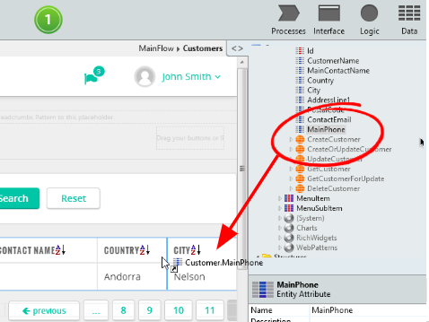
  1. Modify the other columns in the interface.  
     1. Select column “**Country**” of the table
     2. Use the “**Delete Column**” action at the top to delete the “Country” column.

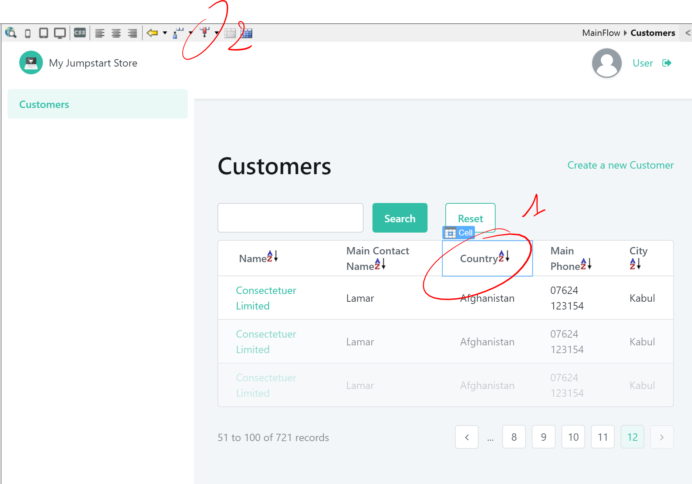

* + 1. Change the labels:
       - “**customer name**” to “**Name**”;
       - “**main contact name**” to “**Main contact**”;
       - “**main phone**” to “**Phone**”.
  1. Create Customers detail page
     1. Go back to the **Main Flow** page
     2. Drag the **Customer** entity to the main flow again.  
        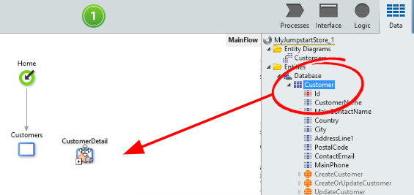  
        *Notice that doing this the second time, OutSystems auto-creates the Detail page and links it to the Listing page previously created. The detail page allows creation, viewing and editing Customer details.*
  2. You can deploy your application by clicking the 1-click-publish button ().   
     *This will start the deployment and publication process with one simple click. During this process, the Development Studio will upload the model definition of your application, and the server will generate standard code C#, HTML5, CSS3, JQuery, Javascript, SQL, optimize it, compile it and publish it on the MS IIS application server*

**You have built your first application!**Open it in the simulator () to test it.

Login with your environment credentials.  
  
Try clicking around, and resizing your browser to see how it looks like in smaller screens.

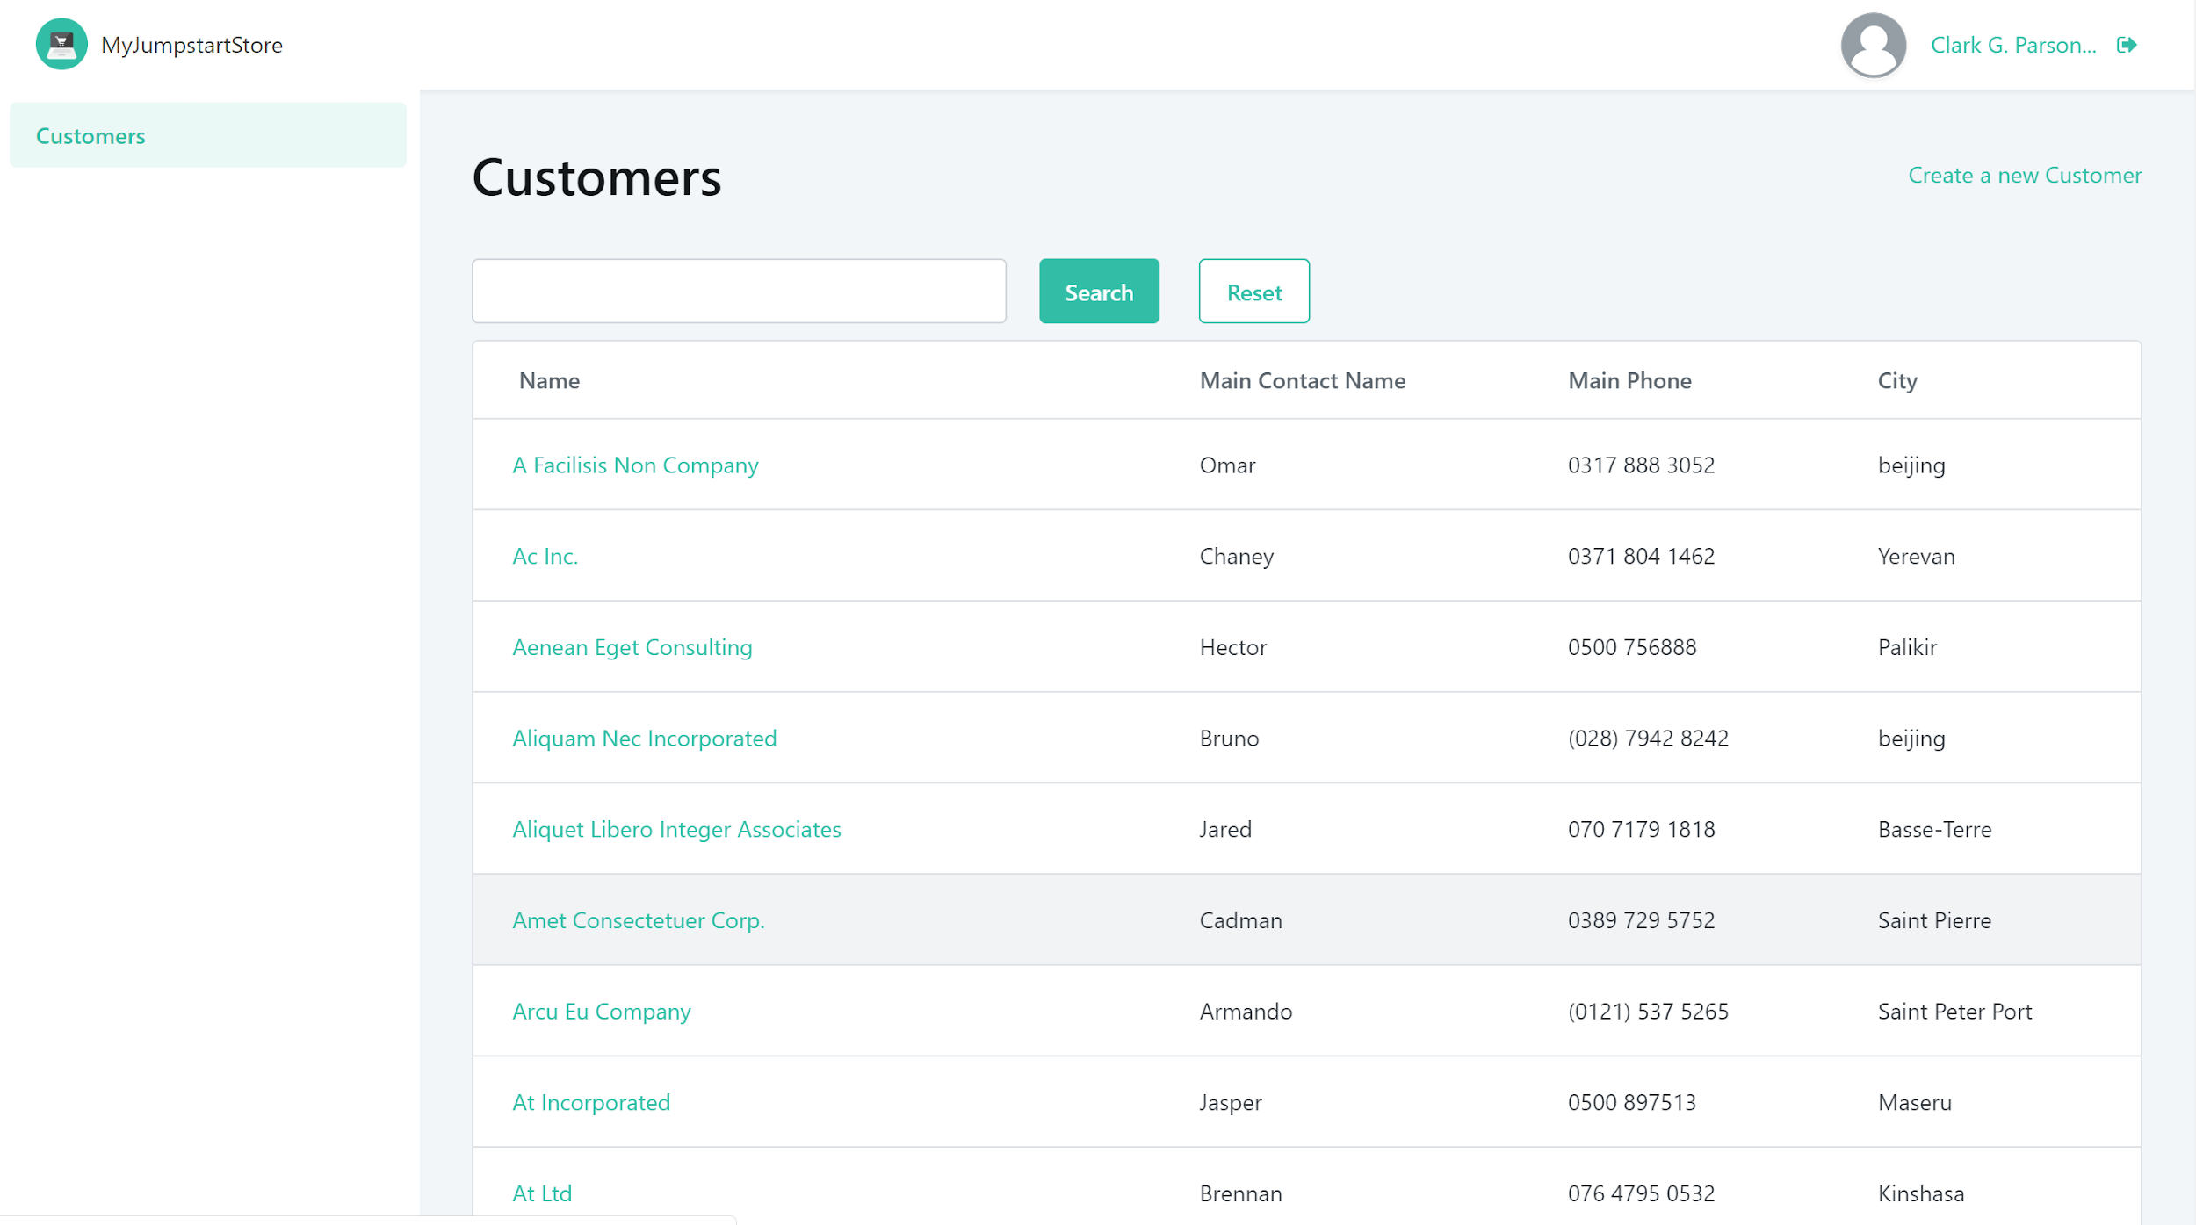

# Automatic Data Modelling (Product)

|  |
| --- |
| In the previous chapter, you created the Customers entity by entering the Entity name and attributes manually.  In this chapter, we will create the Product Entity automatically using an Excel file. |

* 1. Drag the **Gadgets Catalog.xlsx** to the **Data** tab.

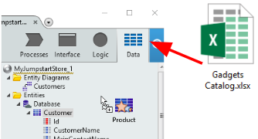

You’ll notice that the **Product** entity is automatically created.

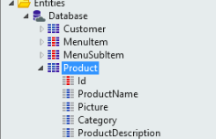

* 1. Open the Entity Diagram **MyJumpstartStoreDataModel** and drag the **Product** entity into the canvas.

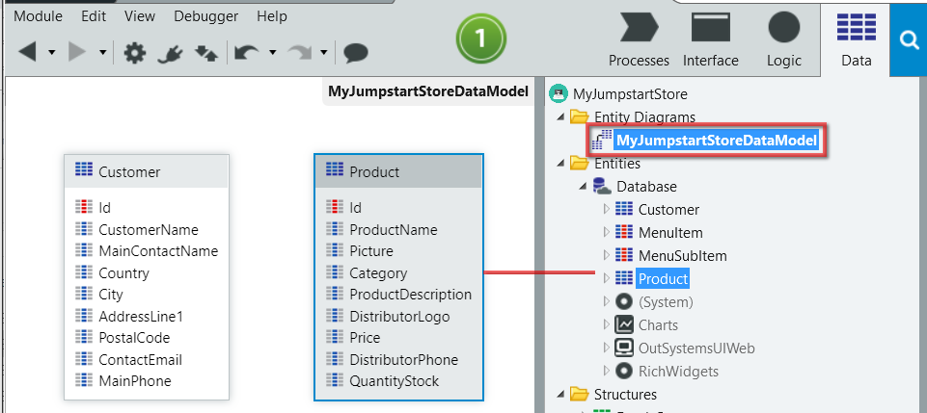  
As what you can see, our **Customer** entity and **Product** entity do not have a relationship yet.

# “Product” Page Creation

|  |
| --- |
| You’ve previously learned how to use the “Scaffolding” feature to automatically create the Customer listing and detail pages. We will do the same for the **Products** entity. |

* 1. Navigate to the **Main Flow** again by clicking the **Interface** Tab and **Main Flow**.  
     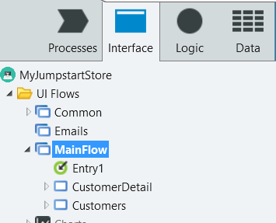
  2. From **Data** tab, drag the **Product** entity twice into the MainFlow Canvas to create both pages (list and edit)  
     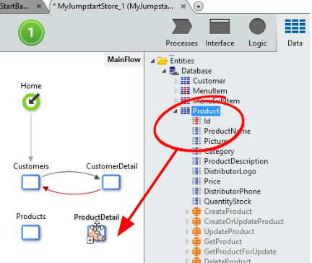
  3. Feel free to navigate into the new pages and tune them to your preference (e.g. such as removing the picture URL from the product list, and display other attribute)
  4. Deploy the application. If you have the browser still open, you can simply refresh the page to test it out.

# “Shipping Details” creation

|  |
| --- |
| Using the Excel sheet **ShippingCompanies.xls** you can now create the Entity and Pages automatically as how you did it in the previous steps. |

* 1. Use the **ShippingCompanies.xls** excel file, and repeat the previous steps to create a **ShippingCompany** entity and the corresponding pages (list and detail page).

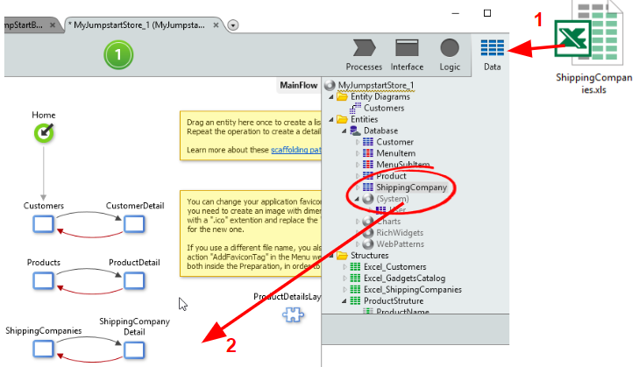

# “Order” and “Order Lines” creation

|  |
| --- |
| In this chapter, we will create the **Order** and **OrderLine** entities and define the Data relationships across all our Entities for this application. |

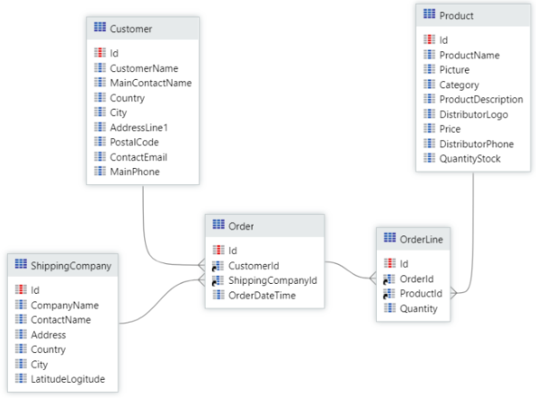

* 1. Create the entity **Order** with the following additional attributes and their data types:
     1. **CustomerId**, Customer Identifier
     2. **ShippingCompanyId**, ShippingCompany Identifier
     3. **OrderDateTime**, Date Time

Note that by creating attributes with an existing entity prefix (e.g. **CustomerId**), the data type will be an entity identifier (**CustomerId** is an identifier to **Customer** entity). Please make sure that your data model, including the attributes, are correctly created.

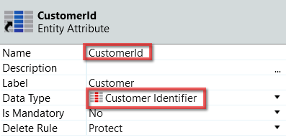

* 1. Create the entity **OrderLine** with the following additional attributes and their data types:
     1. **OrderId**, Order Identifier
     2. **ProductId**, Product Identifier
     3. **Quantity**, Integer
  2. Drag **ShippingCompany**, **Order**, and **OrderLine** entities to the **MyJumpstartStoreDataModel** entity diagram. It should be similar to the diagram above.
  3. Create **Order** pages.  
     Drag the **Order** entity *twice* to the *MainFlow* canvas to create both pages (list and edit)  
       
     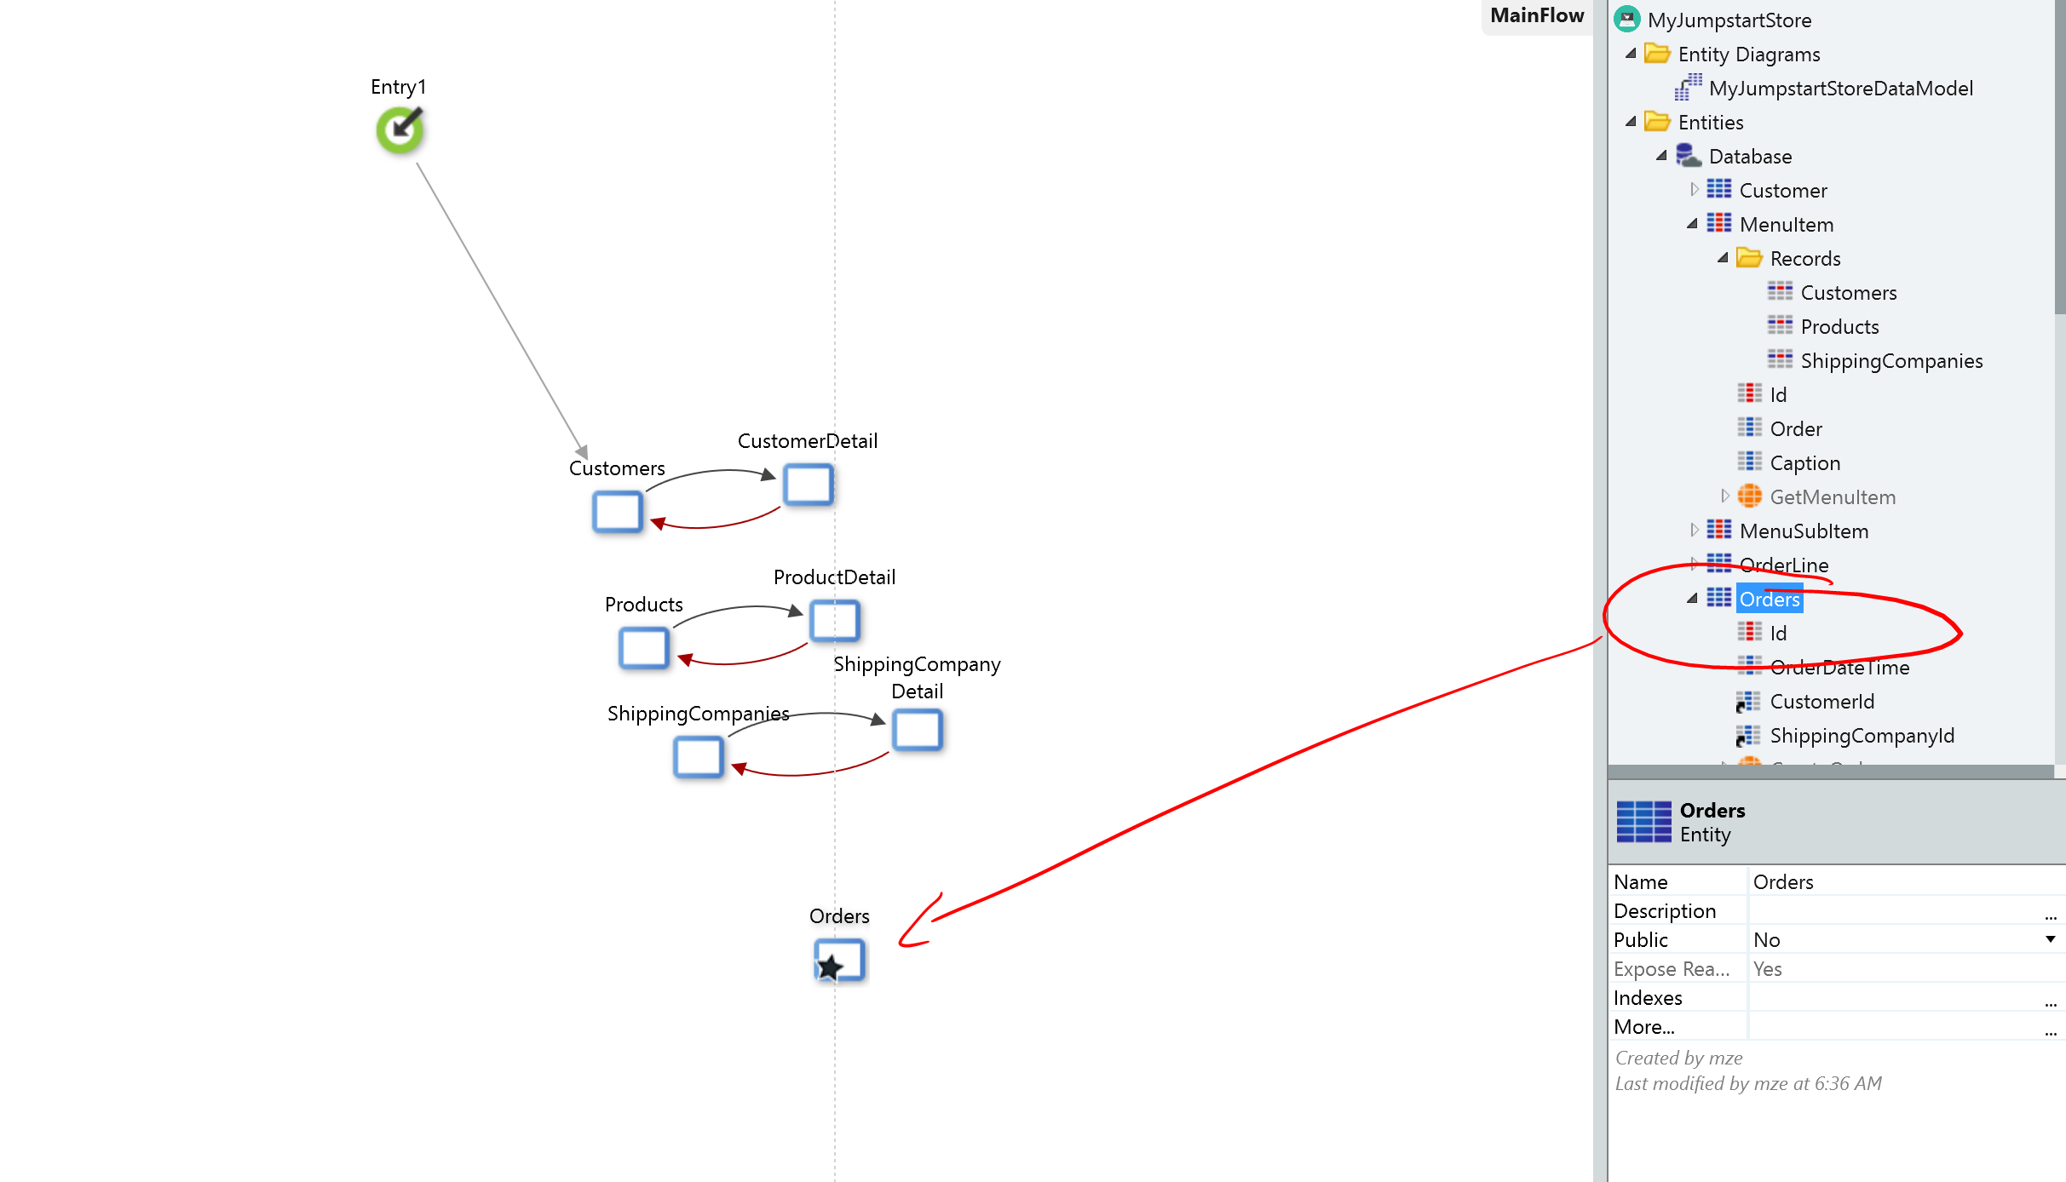
  4. Link **Orders list** to **Order detai**l page

Open **Orders** Page.  
Drag the the **Id** attribute from **Order** entity as the first column of the table to display the ID of each Order.

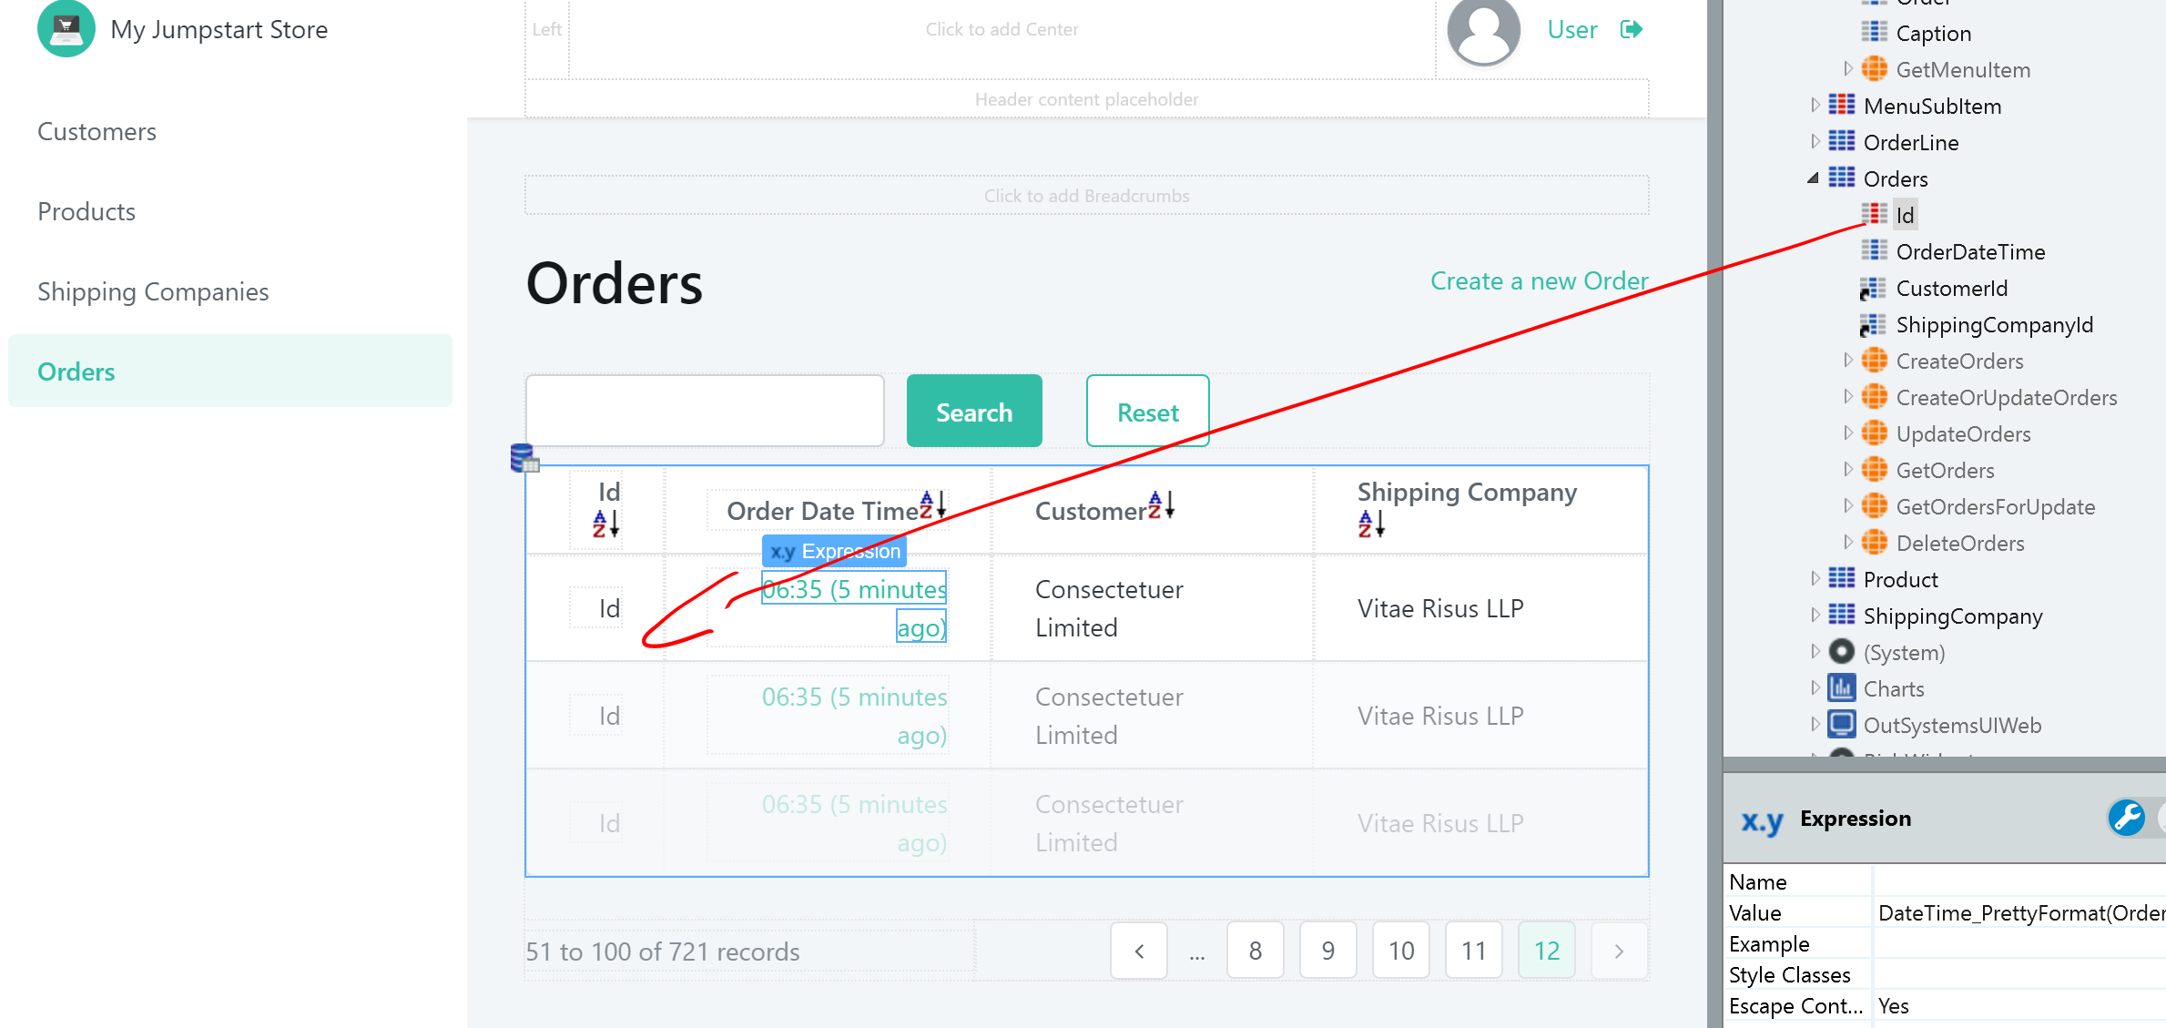

* 1. *(If the* ***Order Date Time*** *is hyperlinked)* Right Click on **Order Date Time** Row and select “**Unlink**”

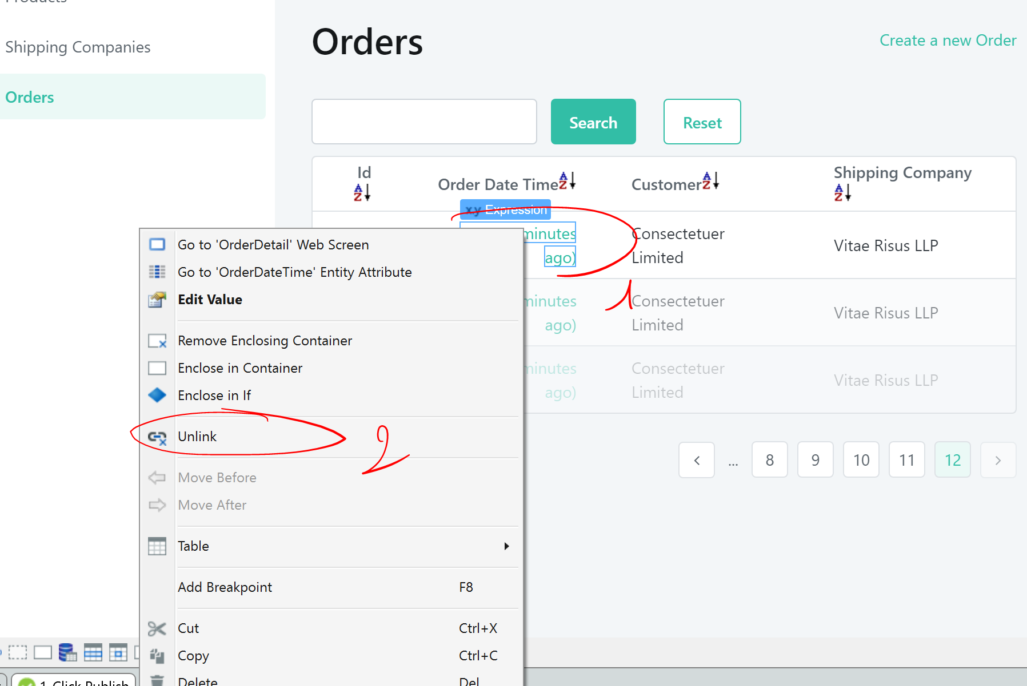

* 1. Select *expression* that shows the **Id** attribute. Make sure the *expression* control () is selected.

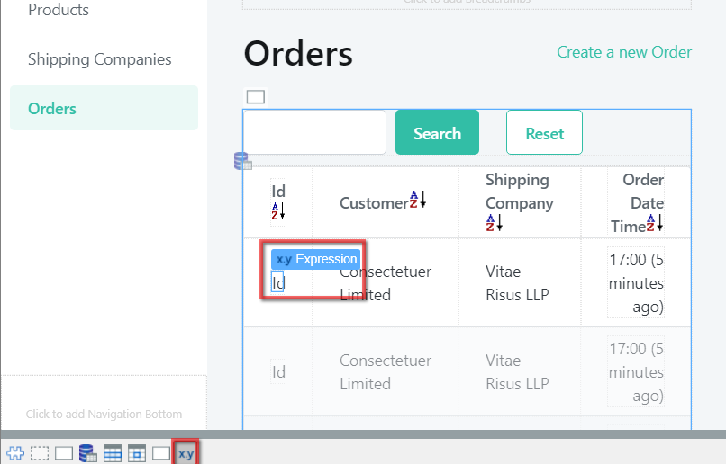

Right click > select “**Link to…**” option to create a link to the OrderDetail page  
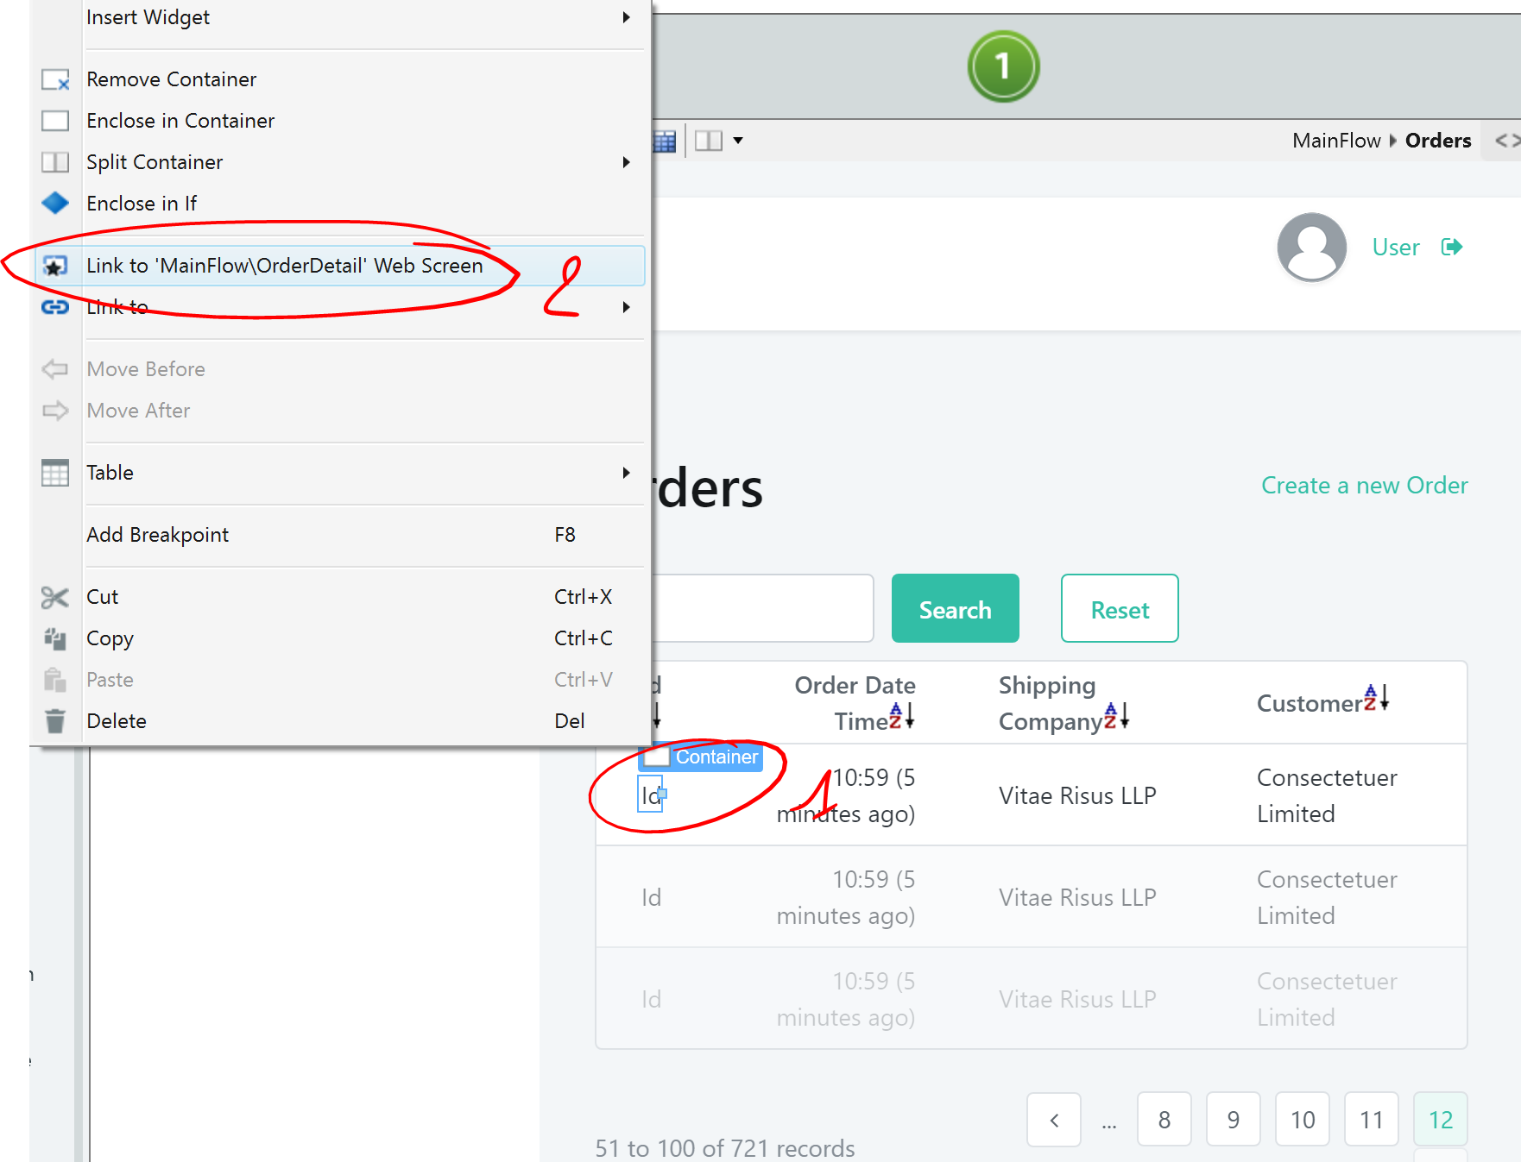  
  
  
If you see an error for the input parameter, select the input parameter **OrderId** = **OrderTable...Order.Id**

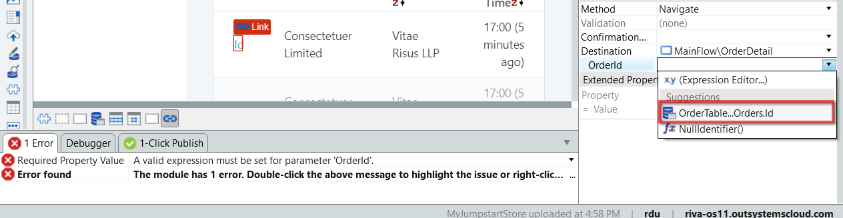

* 1. We will now add order lines into the order.  
     Go to the **OrderDetail** page.  
     Drag the **OrderLine** entity into the interface, below the existing form buttons.  
       
     Notice the auto-creation of an interface to add order lines into orders.

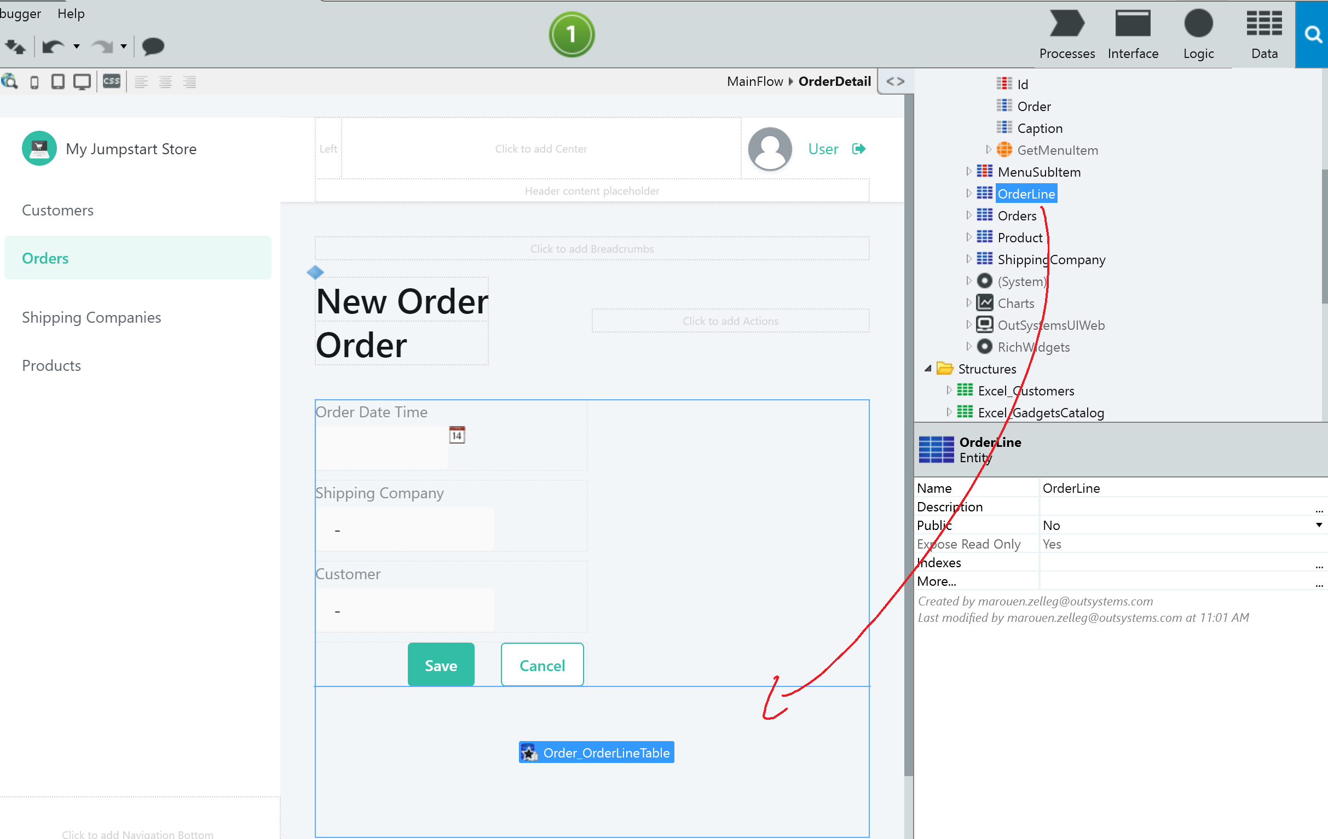  
This is because OutSystems detected that **Order** and **Order Line** has a one-to-many relationship, allowing you to associate many Order Line items (Products) to each Order (Order Detail).

* 1. Deploy and test your application.

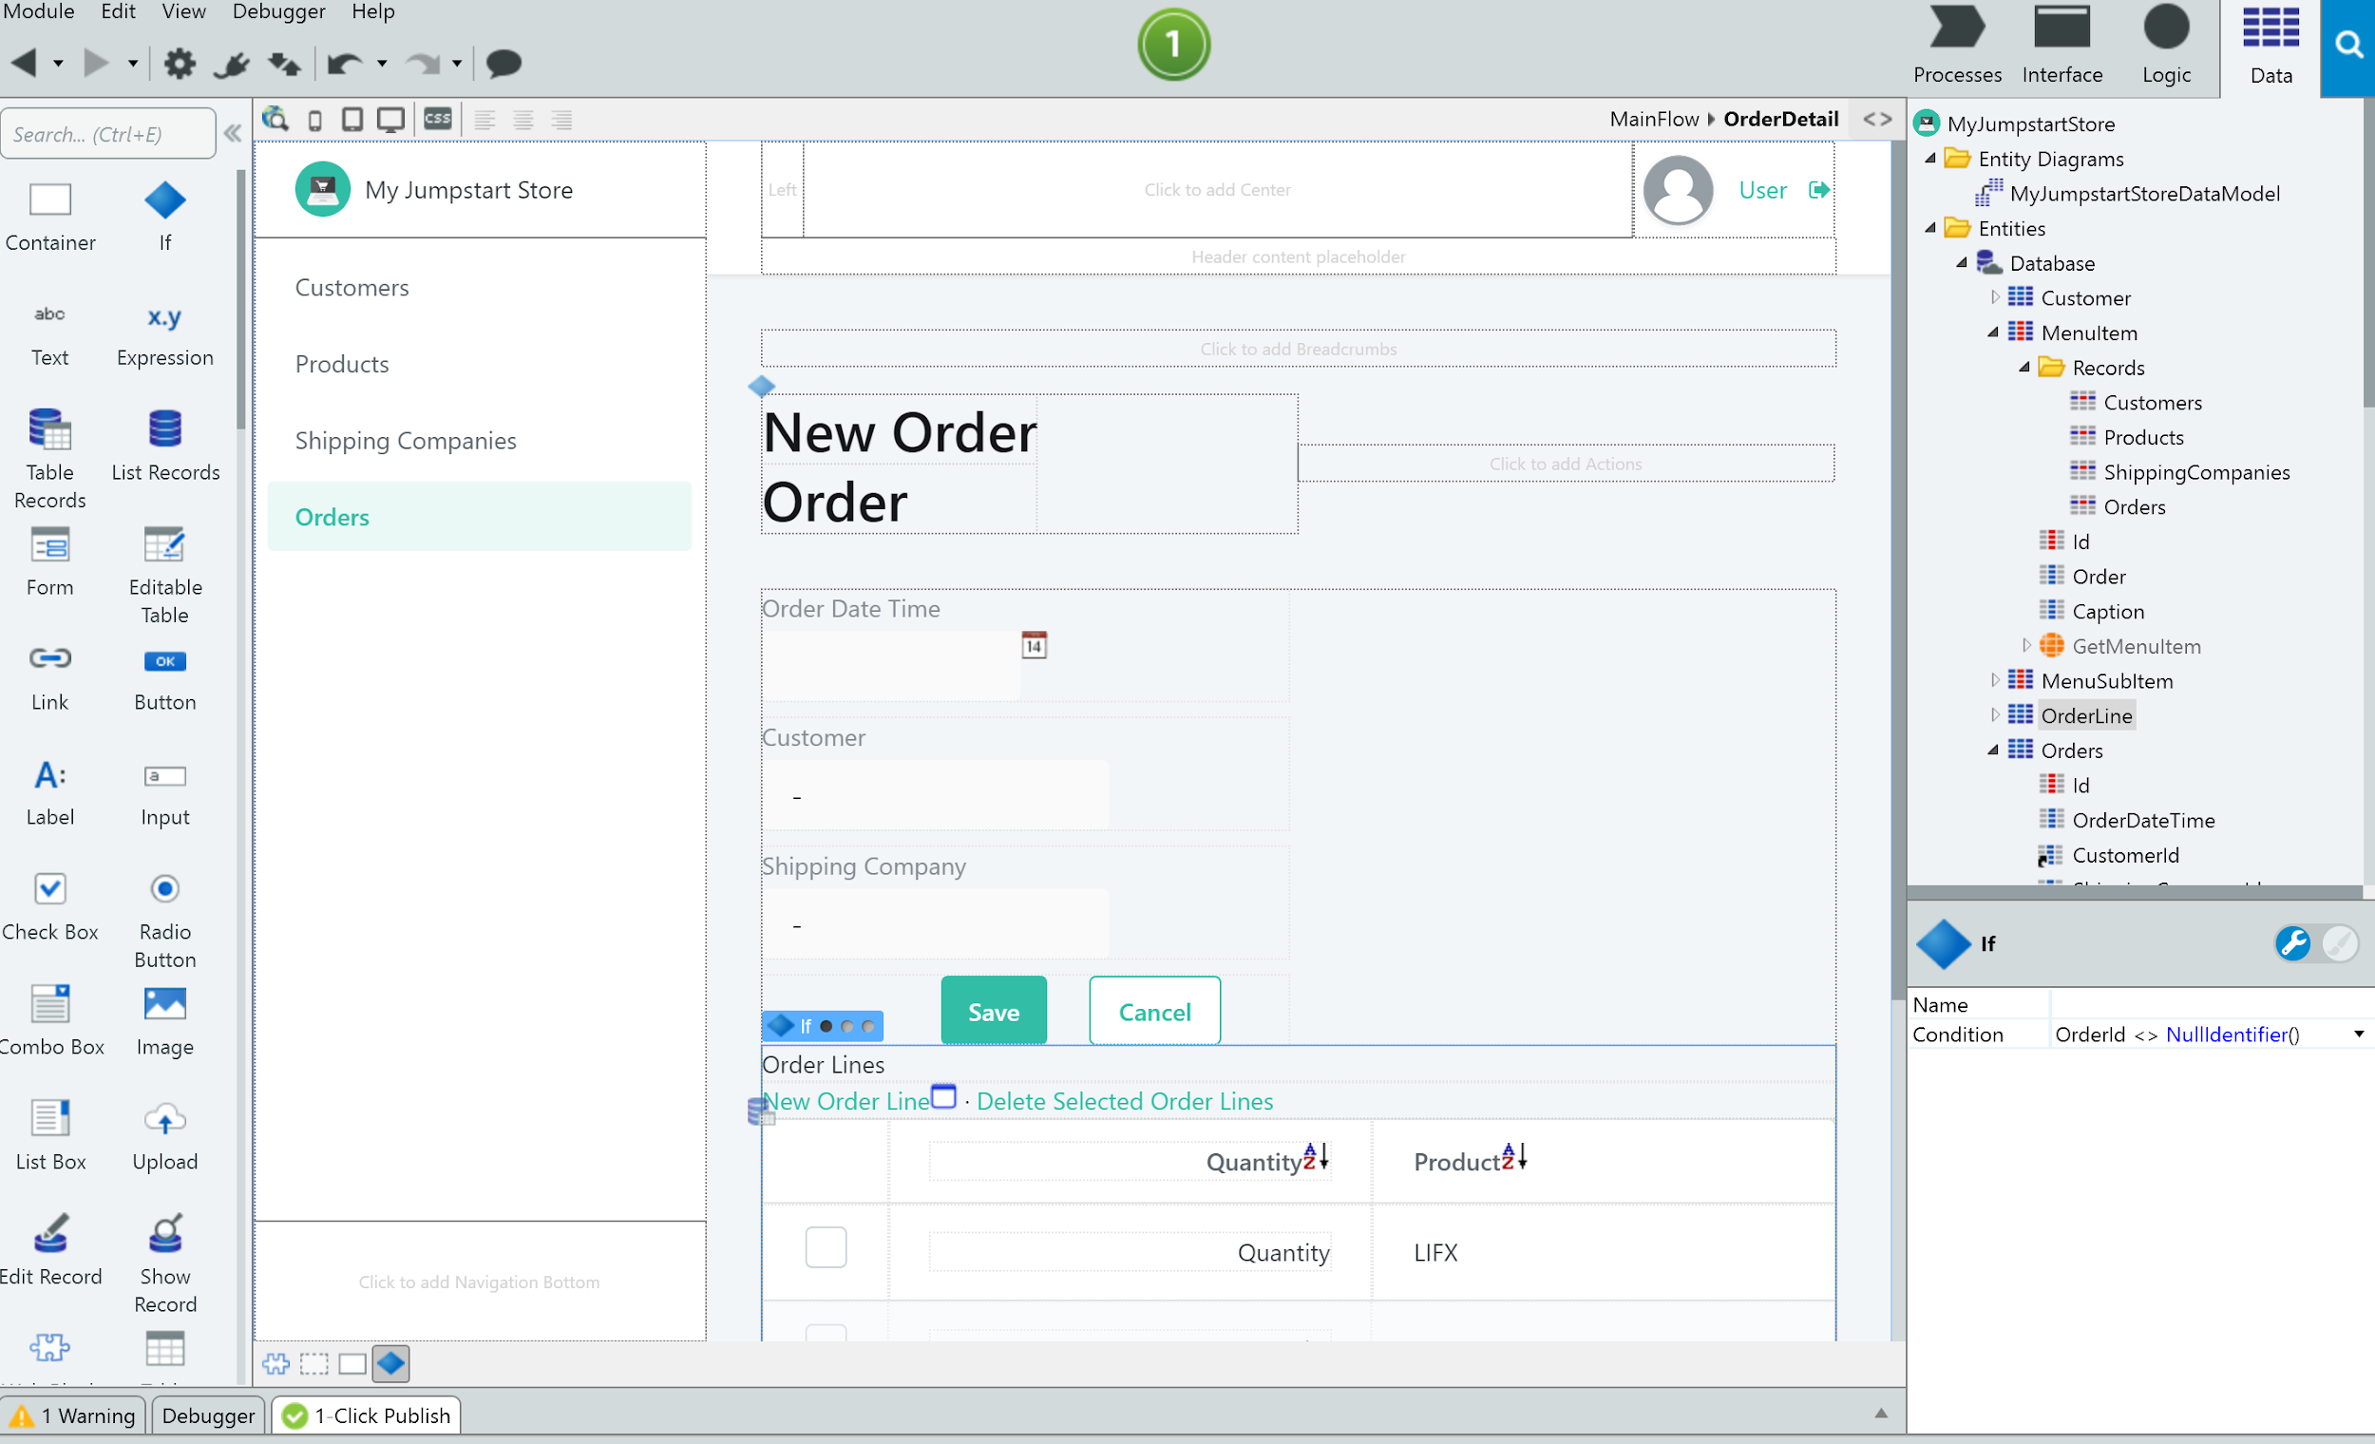

# Gallery Creation using a UI Template

|  |
| --- |
| The platform provides screen templates to help developers create world-class User Interfaces easily. Not only do the Templates contain UI design, but it also has pre-created actions to accelerate development of the page actions such as filters.  OutSystems UI templates pre-creates your screens with sample data that can be easily replaced so you don’t have to start from scratch.  In this chapter, we will create a Product Gallery page that contains a filter. |

* 1. On interface section, create a new web screen into the “**MainFlow**” and called “**Homepage**”

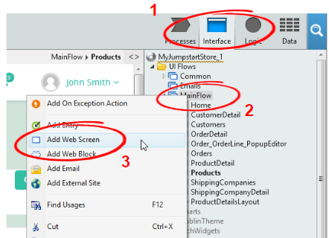

* 1. Select **Galleries**>**Four Column Gallery**Enter name **HomePage**

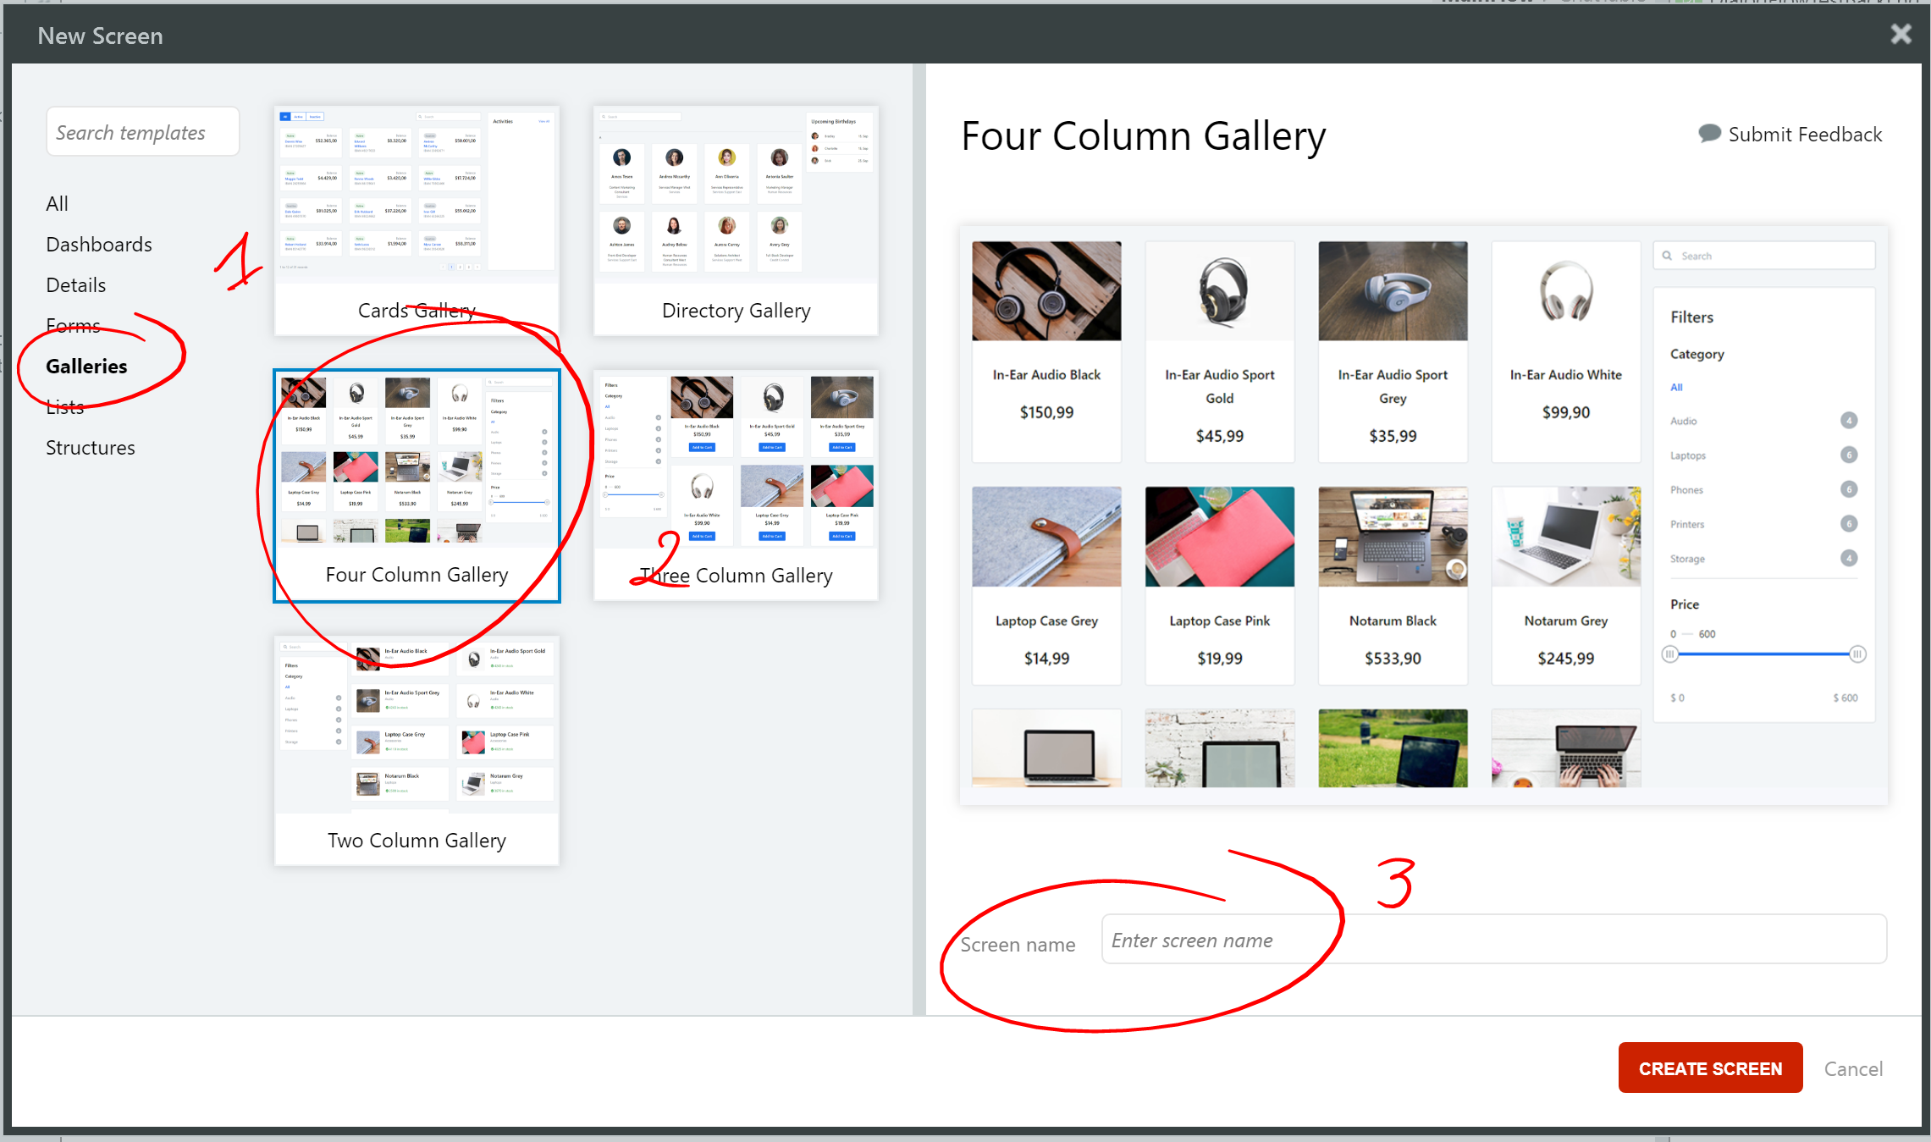

* 1. A page with pre-built template is automatically created.  
     Notice that it’s using Sample Data “**Sample_Product**” and “**Sample_ProductCategory**”.

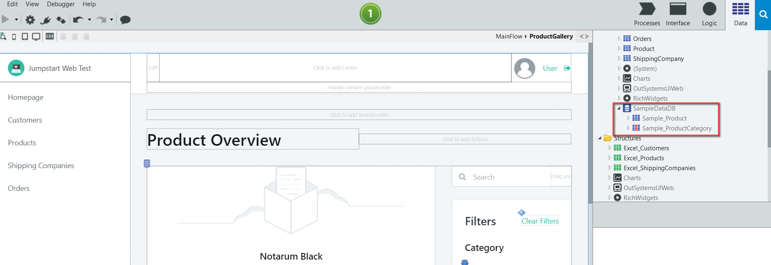

With UI Templates, not only is the User Interface pre-built, it also includes the backend actions related to the User Interface (in this case, filter actions).   
To make the UI and backend actions work, the UI Template comes with Sample Data as a placeholder.

In actual projects, we would need to replace the Sample Data with our own data, including pre-built backend rules (such as filters) that reference to Sample Data.

* 1. In the **Homepage** screen, drag **Product** onto Product Overview section. Make sure it indicates “**Replace Data with Product**”

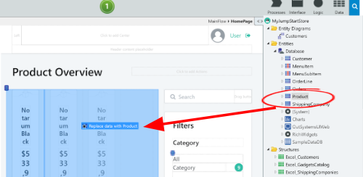

* 1. Click on the Product Image with the orange highlighted warning.

Since the original Image utilized picture data from the sample database, we need to change the attribute on that block to point to what our data uses - an External product picture URL. Change the Image property **Type** to **External**, and under **URL**, select our Database attribute **MainList.List.Current.Product.Picture**

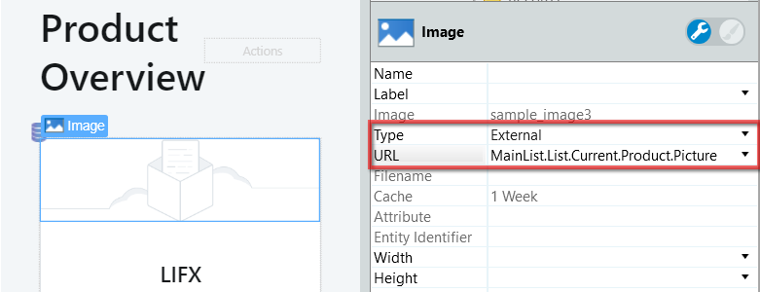

* 1. **Delete** the Category filter controls because we don’t need its feature in this exercise.

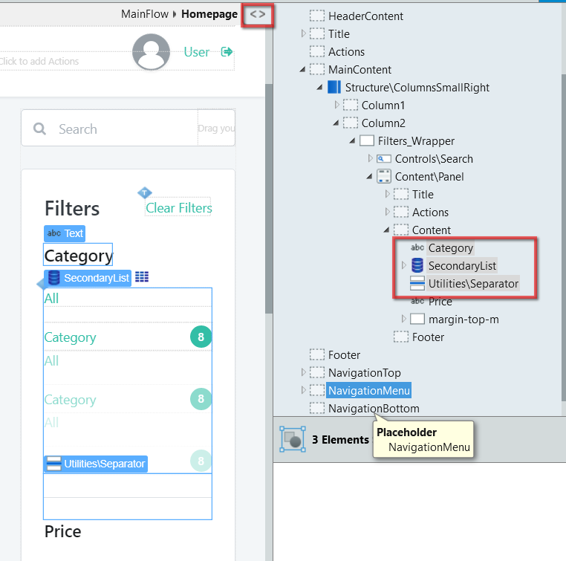

Templates are starting points with common patterns that have most of what you need using Sample Data that can still be fully customized visually.

* 1. Add the **HomePage** to the Menu bar by dragging and dropping the screen into the Menu area.

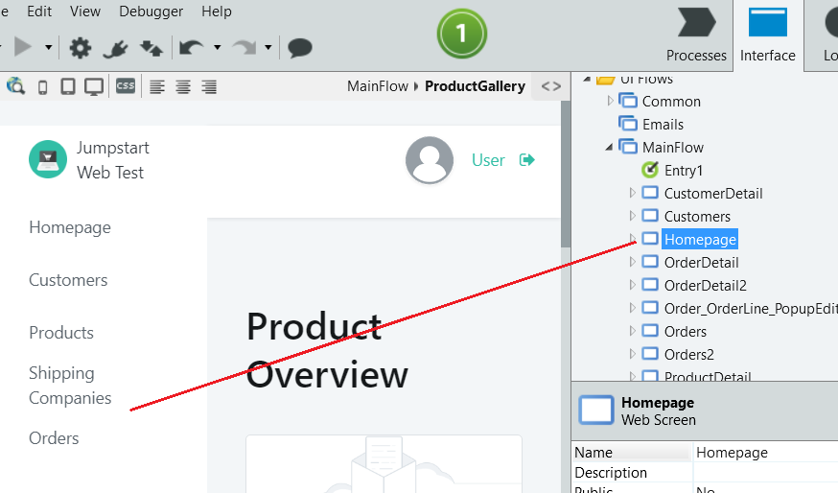

* 1. [Optional] We can modify the Order of the Menu by double clicking the the Menu block

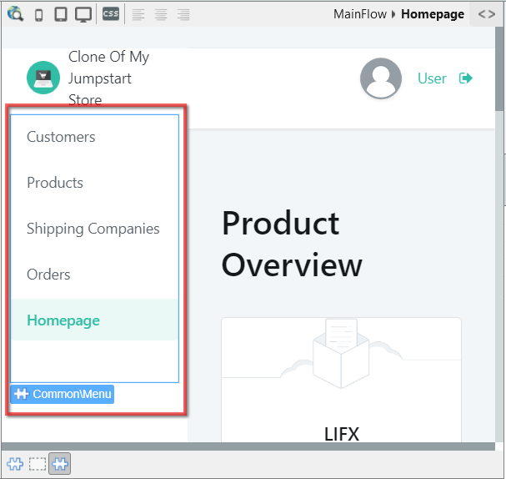

Open the Widget Tree (<>) and drag the Last block to the start of the list.

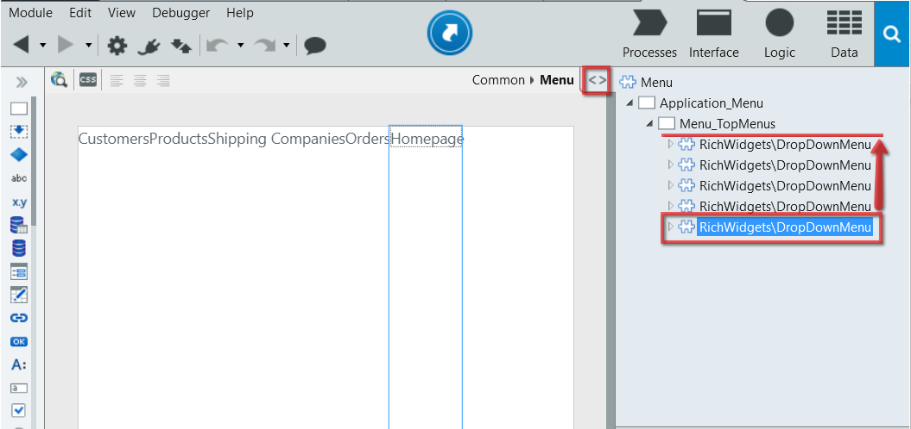

* 1. Set this page as the Entry Point by going to the **MainFlow** and redirect the **Entry1** arrow to the **HomePage.**  
     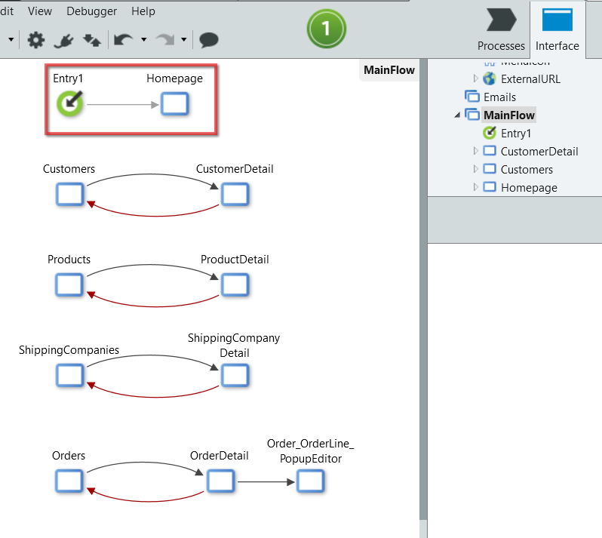
  2. Click “1 Click Publish”.  
     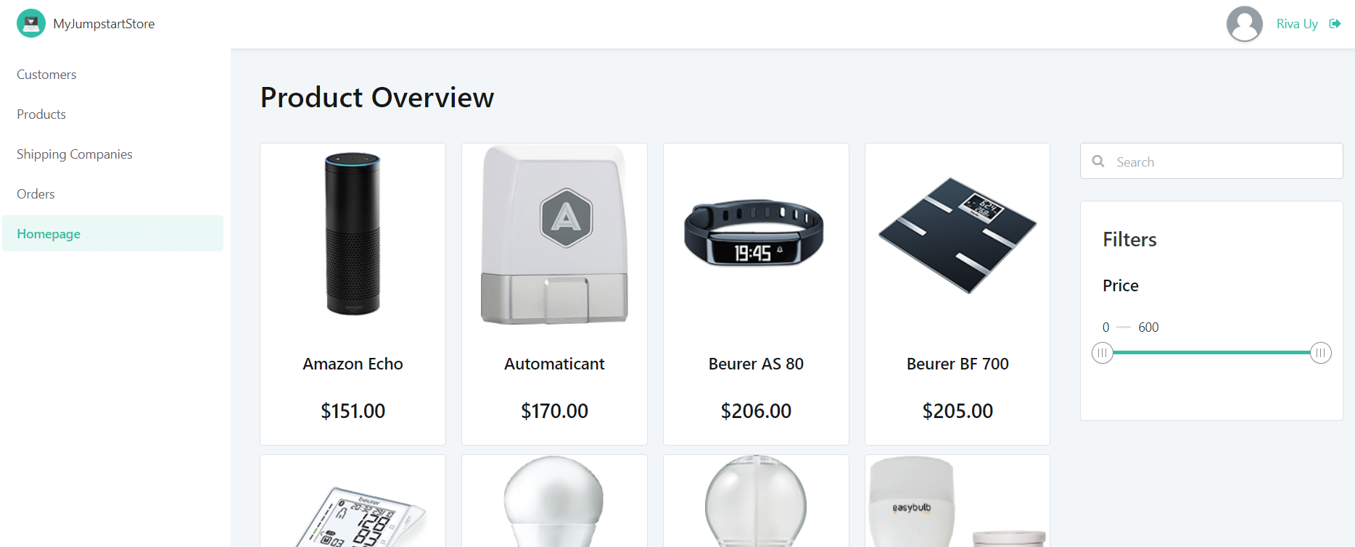  
     *Tip: Resize your browser to see how the page responds to multiple form factors.*

# Expose the **Product** entity as public

|  |
| --- |
| In a later exercise, we will reuse the **Product** entity in our Mobile Application.  We need to expose the Product entity as public to make it accessible to other OutSystems apps. |

* 1. Go to the Product Entity and set the **Public** property to **Yes.**

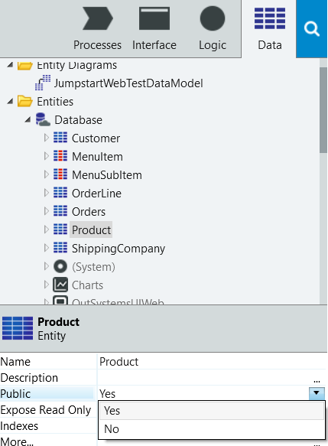

# Expose the product catalog as a REST Service

|  |
| --- |
| This section explains how you can expose your action as a web API that can be consumed by other applications. |

* 1. From the **Logic** section go to the Integrations folder, right click the **REST** item and select **Expose REST API**.

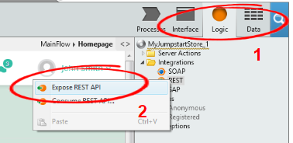

* 1. Rename the API to **Products.**   
     Right click **Products** and add a new REST API Method and rename it to **getProducts.**

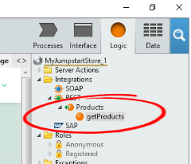

* 1. Right click on the **getProducts** API Method and add an **Output Parameter** with name **ProductList**. Make sure the *Data type* is set to **Product List.**

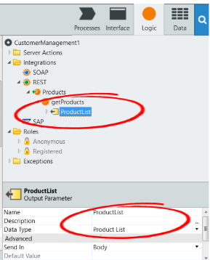

* 1. Double click **getProducts** to design its logic.  
     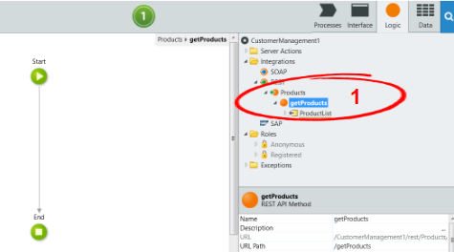  
       
     Drag the **Product** Entity in between “Start” and “End”.

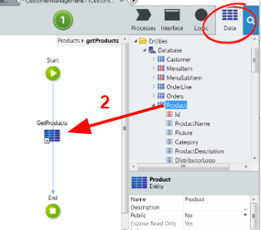

By default, this will automatically create a “**GetProducts**” query to fetch all products from the database.

* 1. Assign the output parameter value by dragging and dropping the **ProductList** Output Parameter into the Action under the new query. From the drop-down, set the assignment to ProductList = **GetProducts.List**.

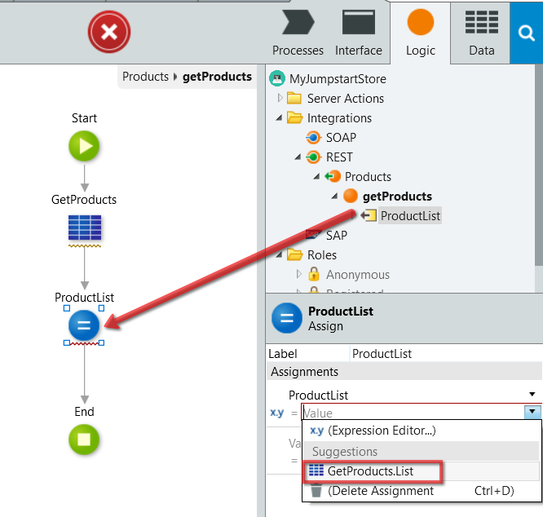

* 1. Deploy your application.   
     OutSystems will automatically generate the REST API documentation upon building.
  2. After the deployment, right click on the **Products** API and click “**Open Documentation**”

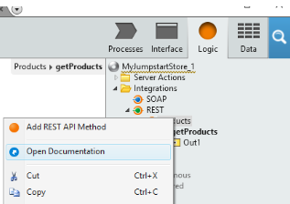

* 1. This is web service **accessible from any other system**. If you enter the Request URL in a browser, you can see the raw JSON returned from the exposed API. Take note of the REST API definition URL at the top of the page. **You can use this later** on for a Bonus section in **Exercise 2**.

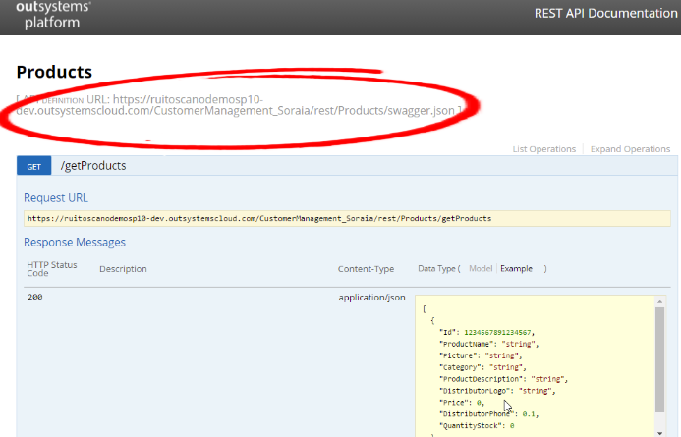

Congratulations! You have completed the first part of this exercise.

**OutSystems JUMPSTART**

Exercise 1b: Advanced Business Logic [~15 mins]

…………………………………………………………………………………………………………

# Calculating Order Total

|  |
| --- |
| This section explains how you can create business logic to compute the Order Line Item total every time the user creates or updates an order line.  We will do the following:   1. **Create a new field in the OrderLine table** to store the LineTotal 2. **Create the business logic** that calculates the total and stores it in the database 3. **Update the OrderDetail page** to display the total per line |

* 1. On the **Data** section go to the entity **OrderLine** and add a new entity attribute **LineAmount** with data type **Currency** to the entity .

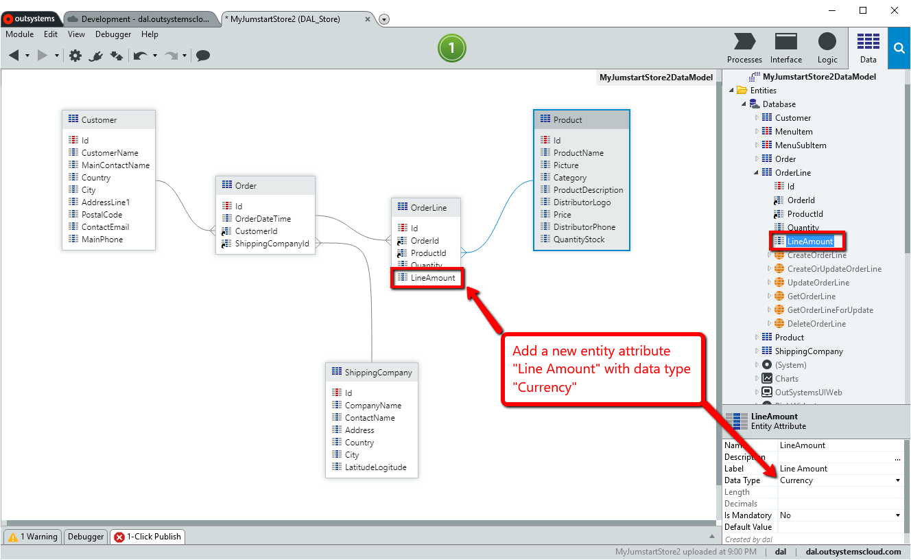

* 1. In the **Interface** Tab, open the “**Order_OrderLine_PopupEditor**” that is where the Order Lines are saved. Double click the **“Save”** button - this will open the “**Save”** screen action that is associated to the **“Save”** button.

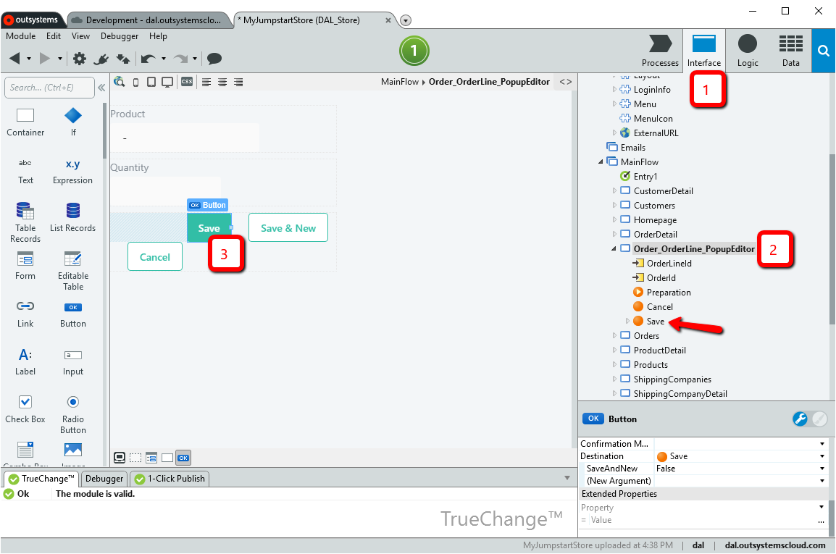

In the next steps we will change the **“Save”** business logic so that it queries the database to get the selected product price, calculates the line item total and stores it in the database.

* 1. In the **“Save”** action flow, drag an **“Aggregate”** from the left tree to the action flow and drop it between the 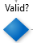 and the 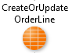items and call it **“GetProductPrice”**.

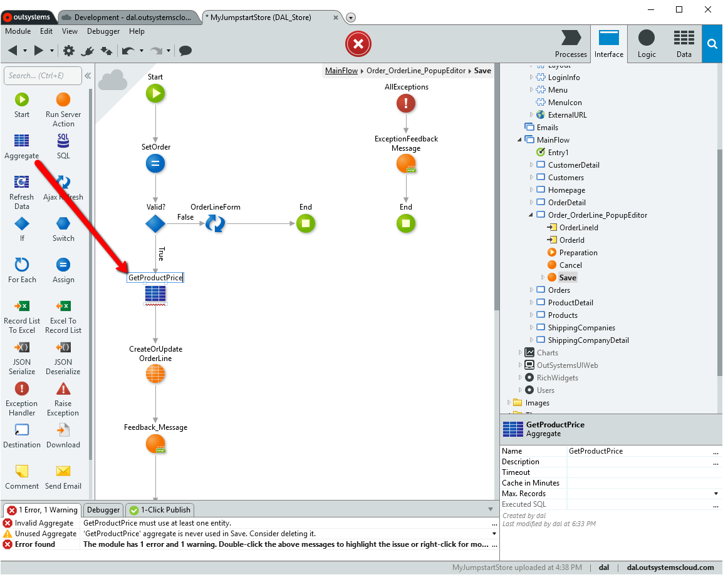

*Note: An aggregate is a visual query designer that can include joins and filters and display real-time data.*

Double click the newly created Aggregate to enter the visual query editor. We are going to create a query that gets the product price.

* 1. Once you are in the the **“GetProductPrice”** Aggregate, drag the **“Product”** entity into the query designer.

This automatically creates a query to get all items from the Product entity.

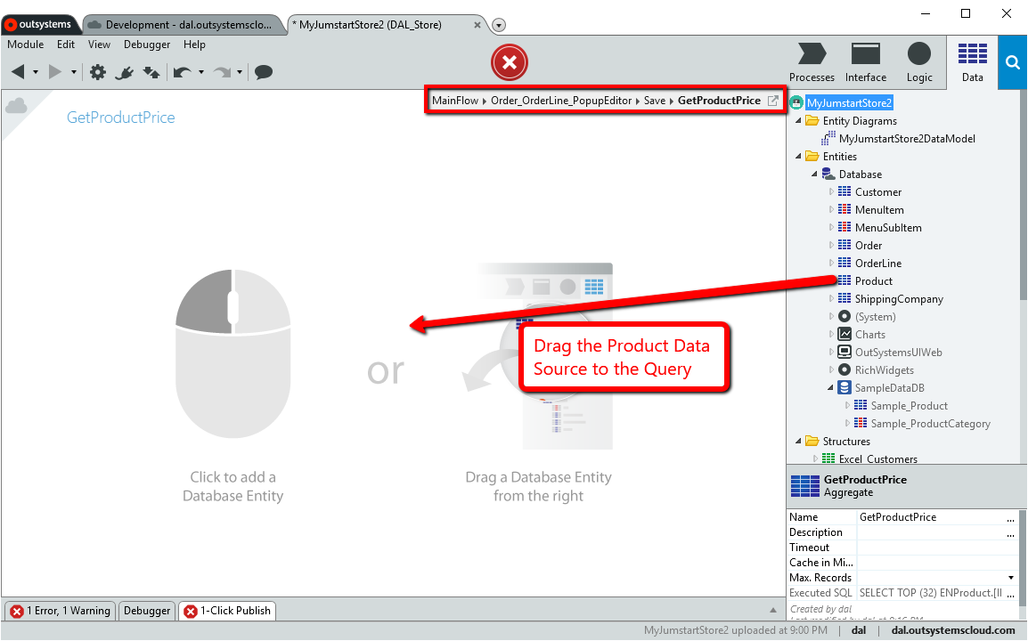

Notice how after adding the **“Product”** table as a data source into the query designer, you can immediately see multiple tabs to configure your query. You can also see the output of the query in real time.

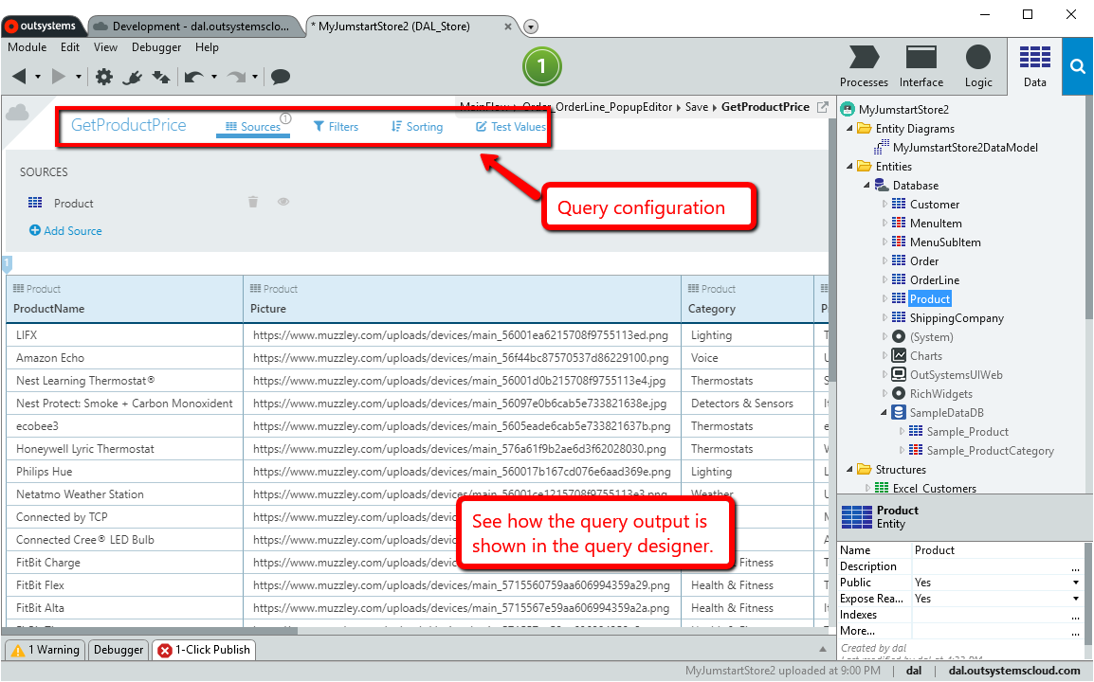

* 1. Click the **“Filters”** tab in the query designer and add the filter. Click the **Add Filter** link and in the Expression Editor input the expression **Product.Id = OrderLineForm.Record.OrderLine.ProductId** and press **Done**.

This will add a condition to the query that will retrieve the product that is selected in the current **OrderLineForm** in the popup screen.

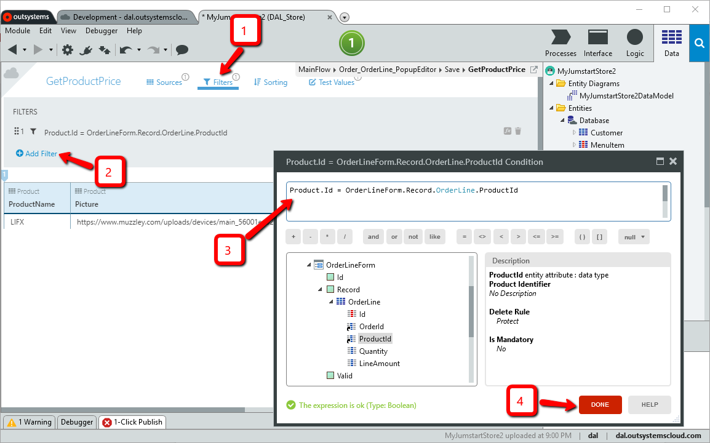

In the **Expression Editor**, you can select elements for the expression directly from what is available in the current **Scope**, seen at the bottom left. It includes all the available parameters, local variables, session variables, site properties, functions and runtime properties in the current scope. You can **drag-drop** the element from the Scope in the bottom-left into the Editor at the top, **or double-click** on them to insert them at the current cursor location in the Editor.

* 1. Go back to the **“Save”** action in the “**Order_OrderLine_PopupEditor**”. You can get there by simply pressing the **breadcrumbs** at the top of the query editor or using the navigation in the **“Interface**” tab on the right tree.

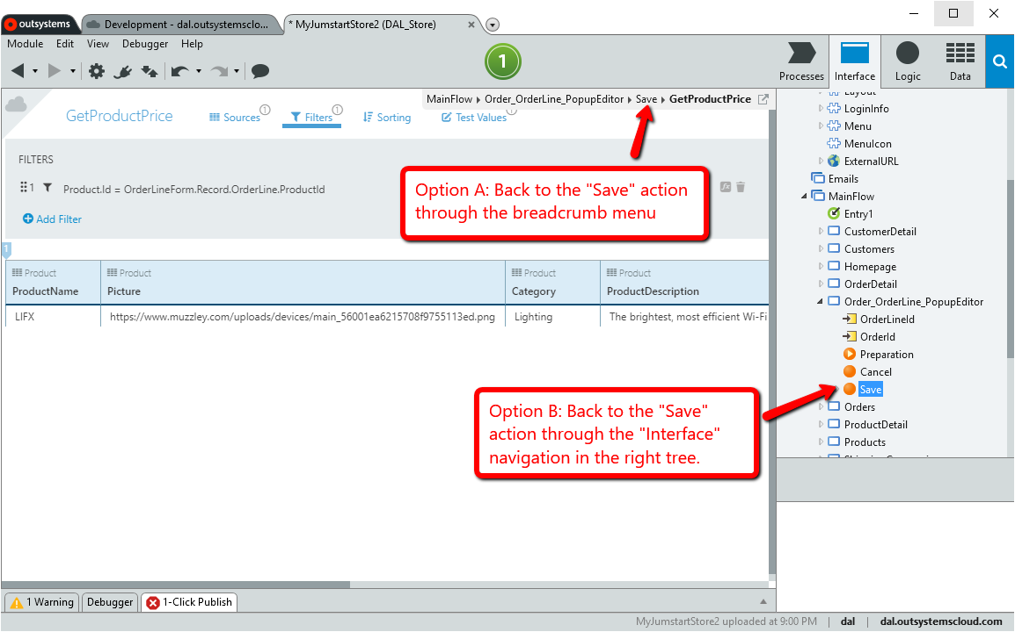

* 1. In the Save action drag an **“Assign”** node after the “**GetProductPrice”** query that you have just created.

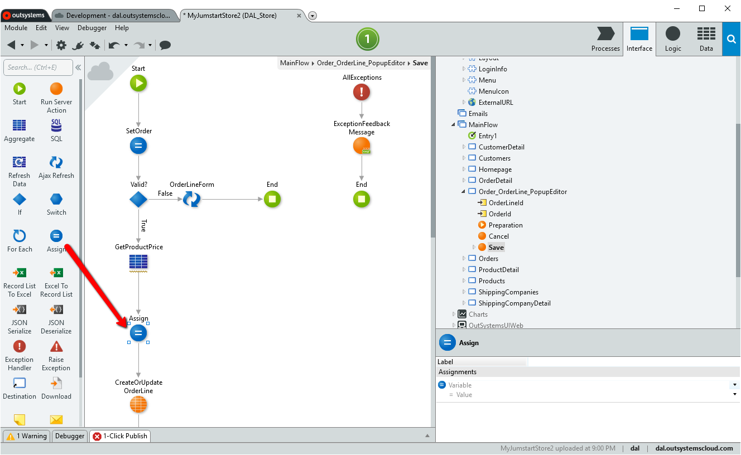

* 1. In the properties of the assign node, set the Variable of the assign note to OrderLineForm.Record.OrderLine.**LineAmount** and the Value to GetProductPrice.List.Current.Product.Price * OrderLineForm.Record.OrderLine.Quantity

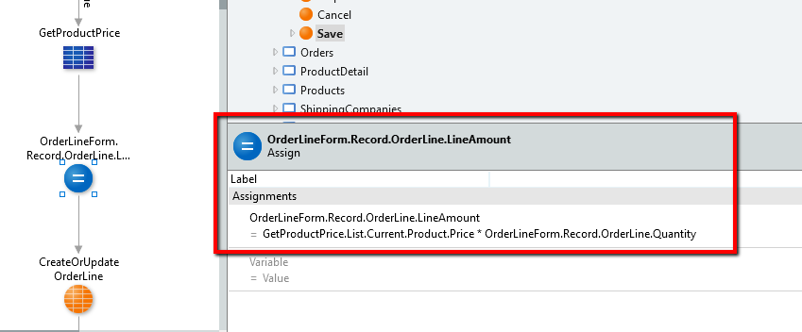

Notice how OutSystems offers you a powerful “Variable Selector” and “Expression Editor” with full impact analysis, autocomplete, highlight, etc.

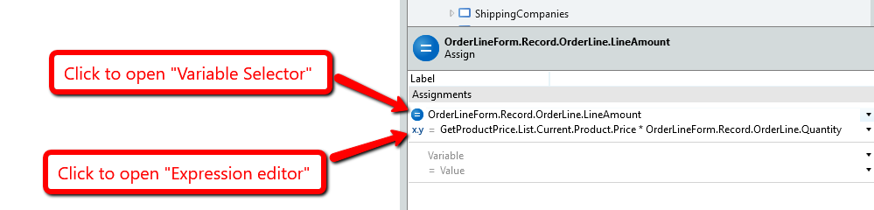

* 1. And voilá. The business logic is done. See below a summary of your work of art!

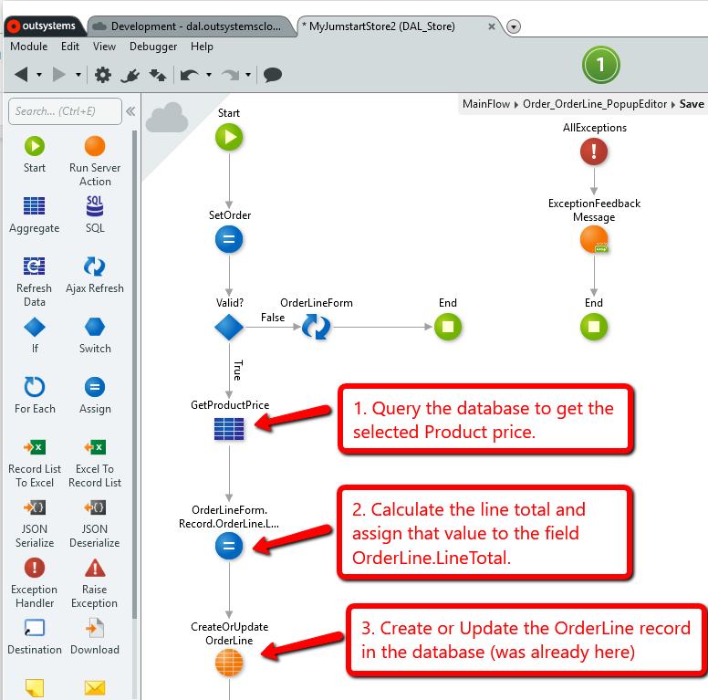

* 1. On the **Interface** section open the **OrderDetail** screen

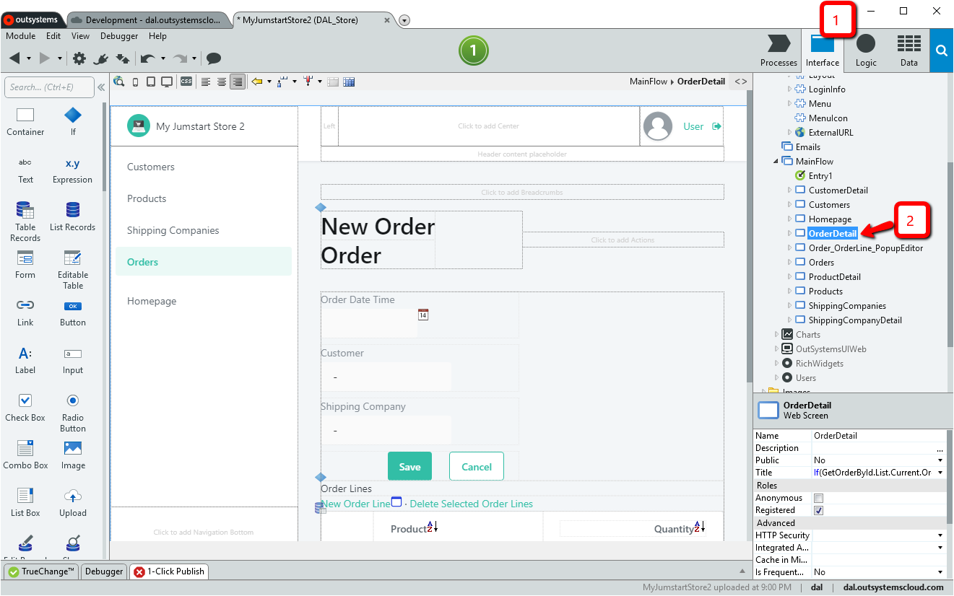

* 1. Click the **Data** section and drag your newly created “**OrderLine.LineAmount”** field to the Order Lines table at the bottom of the screen.

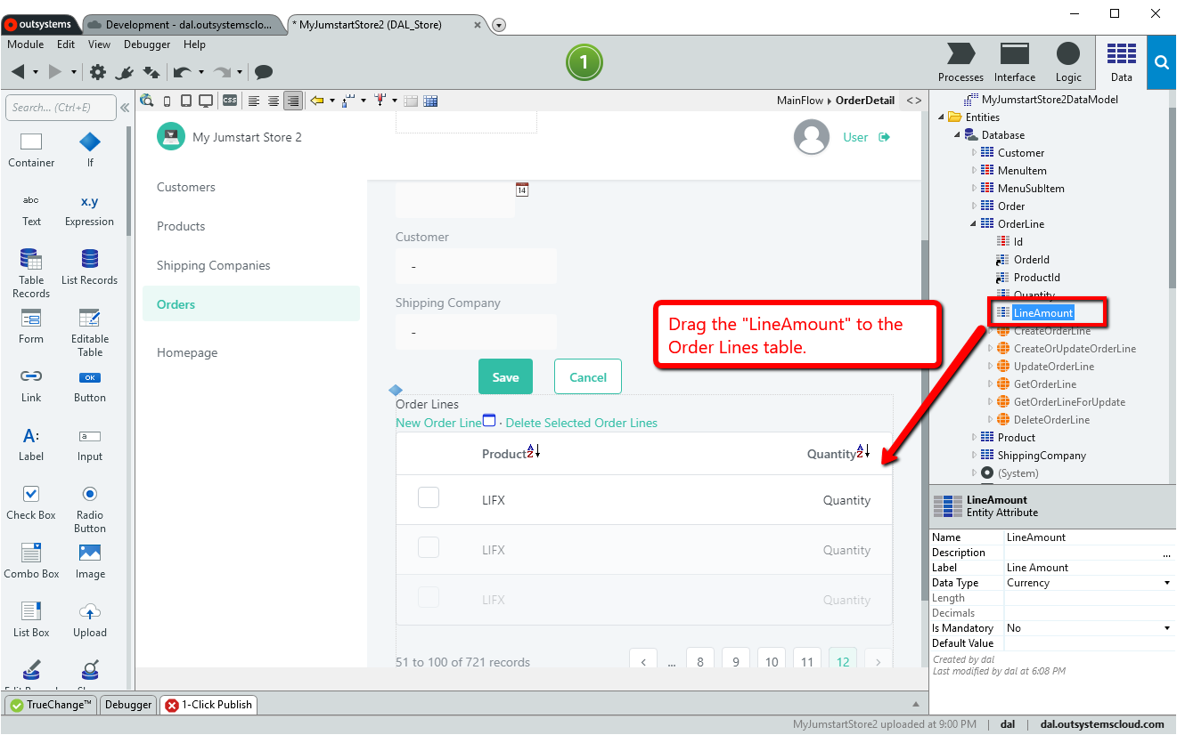

This will update the table on screen so that it now displays the **“LineAmount”** field

* 1. Double click the **LineAmount** expression in the table and change it so that the amount is formatted to your currency - eg. change the expression to FormatCurrency(Order_OrderLineTable.List.Current.OrderLine.LineAmount,"$",2,".",".")  
       
     Note: You can find the built-in **FormatCurrency()** function under: **Scope** → **Built-in Functions** → **Format**. You can **double-click** on it to place it in the Expression Editor, or **drag-drop** it into the Expression Editor.
  2. Publish your application, create a new order and see how the total line amount is now calculated and displayed in the **“Order Detail”** page.

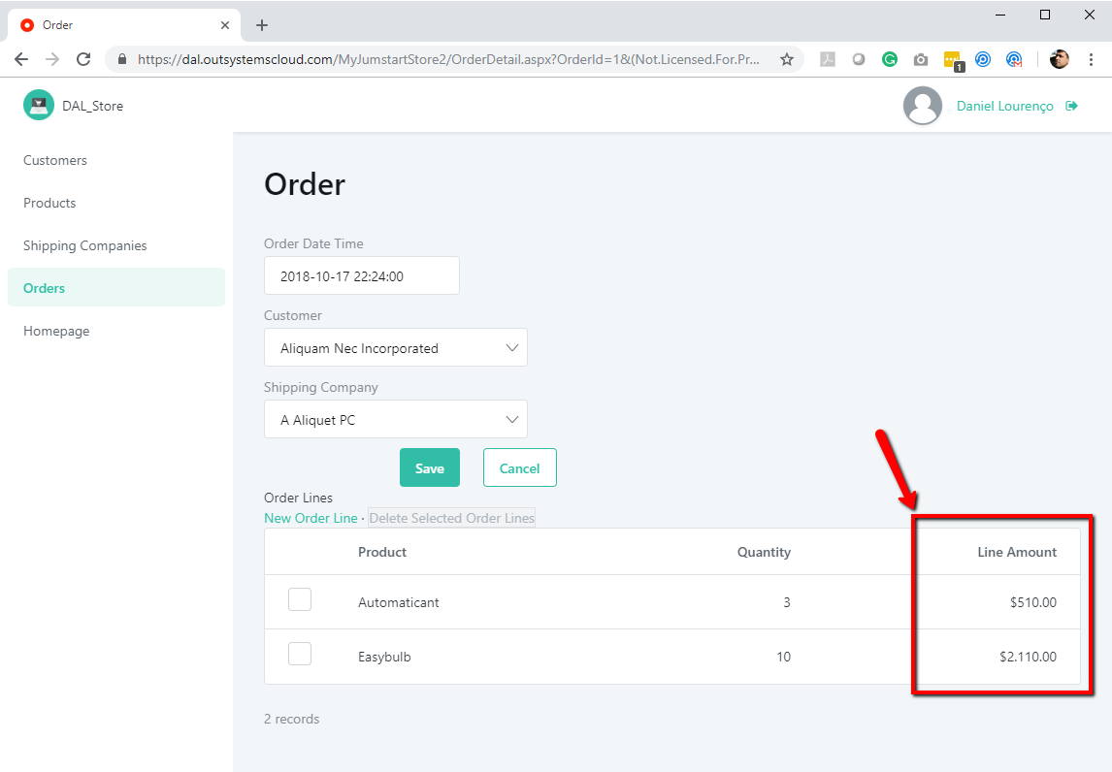

Congratulations! You have completed the advanced exercise!

You’ve now levelled up to an OutSystems Ninja!